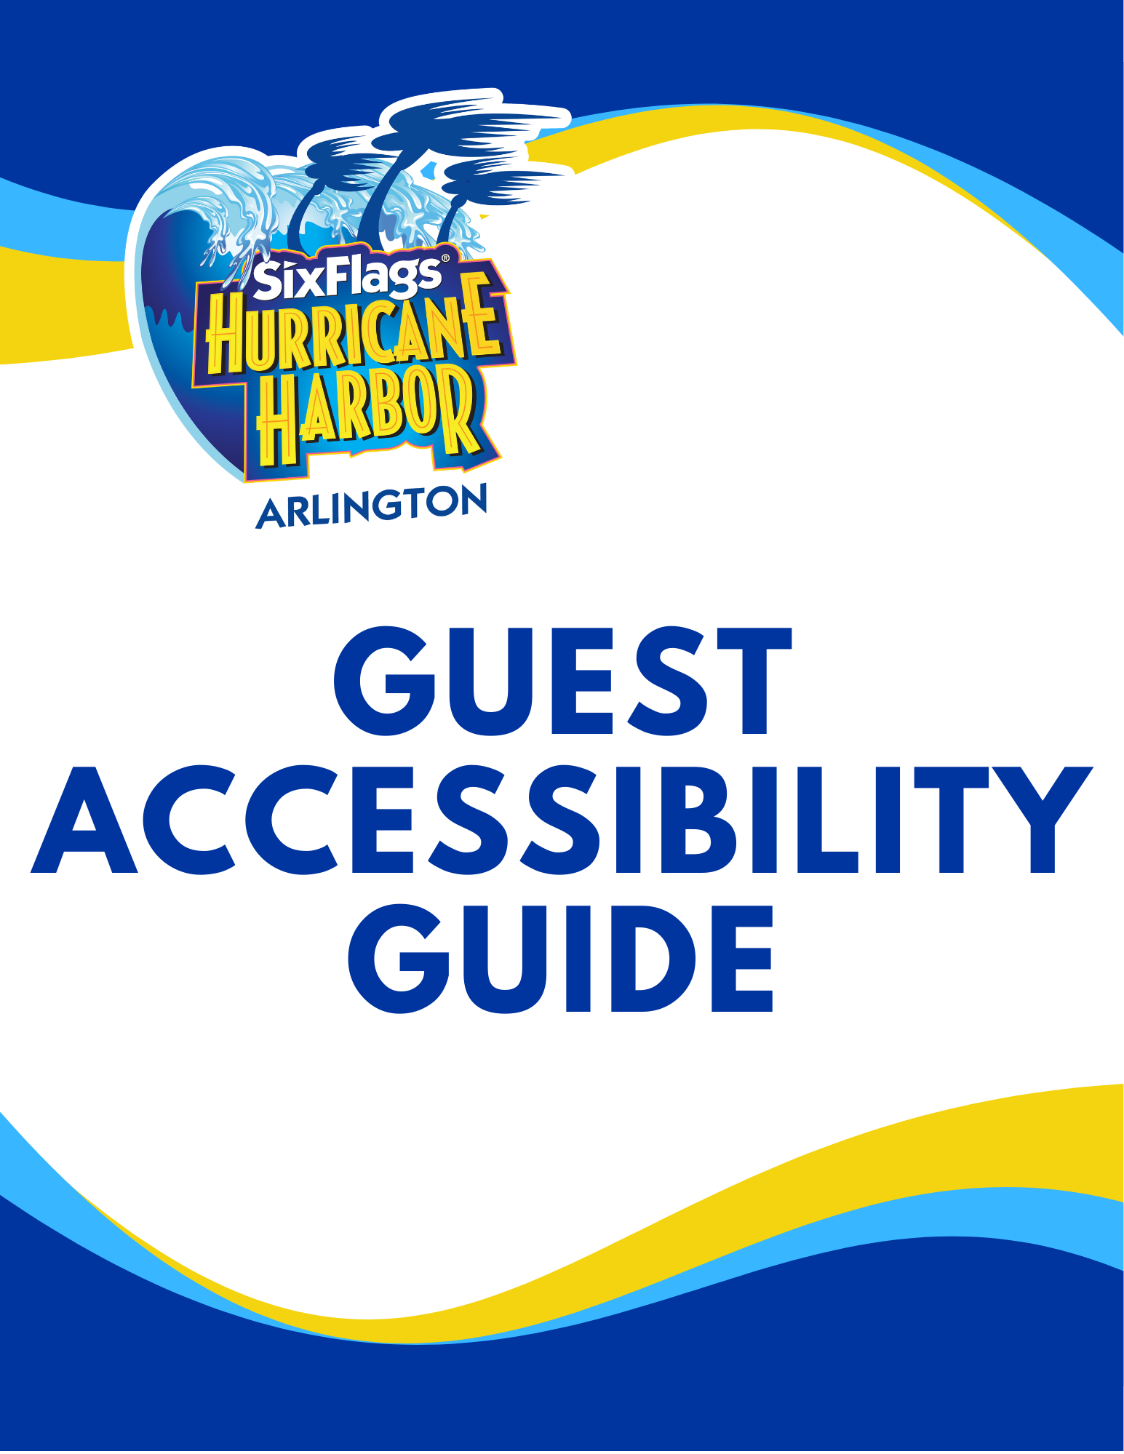

WELCOME TO SIX FLAGS HURRICANE HARBOR!

We are glad you are here! At Six Flags Hurricane Harbor we are proud to have earned one of the best safety records in the industry. We are committed to providing our Guests with a safe environment and we want our Guests to have a safe and enjoyable day. We are continually striving to improve our facilities.
Many amusement park attractions incorporate safety systems designed by the manufacturer to accommodate people of average physical stature and body proportion. These safety systems may place restrictions on the ability of an individual to safely experience the attraction. Guests of larger or smaller size, Guests who have a history of heart, back or neck trouble, Guests who are pregnant, Guests who have had recent surgery, or Guests with casts, braces, restrictive devices or disabilities may not be safely accommodated by these systems. For example, height requirements are based on the size needed to safely participate and the level of maturity usually associated with a certain height.
The Attraction Accessibility Program has been developed using our past experiences and our evaluation of each attraction in both normal and emergency operating conditions. We also work closely with the manufacturer of each attraction and our policies incorporate the manufacturers’ guidelines as well as the requirements of the Americans with Disabilities Act. We hope that this guide will help Guests make the best choices to ensure a safe and enjoyable experience at the park. Our goal is to safely and efficiently accommodate the needs of all Guests, including individuals with disabilities.
Our prime consideration is the ability of each person to endure the dynamics of an attraction without risk of injury to that person or other participants. If you feel that you or a member of your party may be affected by this policy, you are encouraged to visit Guest Relations to obtain a list of attractions you can safely attraction. Your Attraction Access Form will provide information for a Team Member to help accommodate you.
PLEASE PARTICIPATE SAFELY
While all amusement attractions have associated risks, certain individuals are at increased risk for injury from these attractions. Carefully evaluate each attraction to determine if you or members of your party can safely participate. We reserve the right to deny access to an attraction to anyone who we feel may not be able to safely experience the attraction or may be a hazard to other participants.
A Safety Guide sign is posted at every attraction entrance. These signs provide height requirements, weight restrictions, health restrictions, attraction ratings, attraction accessibility, and special instructions regarding the attraction. Please review these signs prior to accessing the attraction and ensure to follow all instructions provided.
In general, all Guests should be in good health and free from any conditions known or unknown, that might be aggravated by riding. If you have any doubt about your ability to safely experience an attraction, we urge you to consult with our team at Guest Relations. Remember, if you suspect your health could be at risk for any reason, or you could aggravate a pre- existing condition of any kind, DO NOT RIDE.
Generally, Guests must have the ability to brace themselves upright in the seat and support their head and neck during the attraction movements. Guests using wheelchairs will have to transfer themselves or assisted by a member of their party in order to be able to participate. You should plan your visit with someone who can physically help you when necessary.
As a Guest, you are responsible for your own safety. Please read this guide and all instructional signage before riding. Listen to and follow all operator instructions. Any person who violates a park safety policy, or appears to be under the influence of alcohol or chemical intoxicants will be removed from the park without refund. FOR YOUR SAFETY, DO NOT ENTER AN UNAUTHORIZED AREA FOR ANY REASON. You may be seriously injured if you enter an unauthorized area.

Before riding, please note all safety warnings for each attraction.
In general:
- Proper swimwear is required to participate on the attractions and in the pools.

- Follow all proper ride positioning until the attraction comes to a complete stop.

- Due to the nature of our attractions, backpacks, purses, electronics, jewelry and other loose items are not permitted on most attractions.

- Glasses must be secured with a head strap.

- Six Flags Hurricane Harbor is not responsible for lost or stolen items. You are responsible for your personal property.

- Due to the nature of our attractions, picture taking, cell phone or electronic usage while riding is prohibited on most attractions.

- Keep all parts of your body inside the attraction unit at all times.

- Finish food and drink before boarding.

- Smoking, including e-cigarettes, is not permitted in Six Flags Hurricane Harbor.

ATTRACTION RATING SYSTEM
An Attraction Rating System has been designed which provides a scale for rating the thrill factor of each attraction. The intent is to provide a scale to guide park Guests in determining which attractions to participate in based on their own experience level, physical condition, and abilities.
Each attraction/attraction is placed into one of five categories:
CATEGORY |  | DESCRIPTION
Low  Thrill Rides | 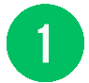 | This is a low speed, and or shallow water attraction.
Mild  Thrill Rides | 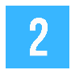 | This is a low to medium speed attraction, and/or water depth to 48 inches. Some Rider control, maneuvering and/or swimming skills required.
Moderate  Thrill Rides | 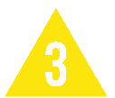 | This is a medium speed attraction. Height and water depth may vary. Moderate or unexpected forces can be generated during the ride. This attraction may require Rider control and/or strong swimming skills. Physical activity may be strenuous.
High  Thrill Rides | 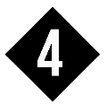 | This is a fast-paced ride experience. Riders will encounter changes in speed, direction, elevation, strong water currents, and/or depth of water, some of which is unexpected. This attraction requires Rider body control and strong swimming skills.
Aggressive  Thrill Rides | 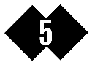 | This is a high speed and/ or deep-water attraction with turbulent turns, drops and/ or strong water currents with changes in speed, direction, elevation and/or deep water, which may be unexpected. This attraction requires Rider body control and swimming skills.

KEY TO SYMBOLS
These symbols, along with the attraction ratings are used to define our attractions on the following pages.
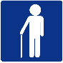 | Ambulatory
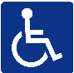 | Accommodates Wheelchair
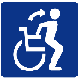 | Transferable
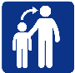 | Must be accompanied by a Supervising Companion of proper height to ride.
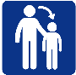 | Must be accompanied by a child to ride/participate.
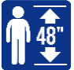 | Must be at least this height to ride.
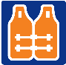 | Lifejacket is required.
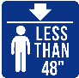 | Cannot be any taller than this to ride/participate.
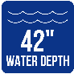 | Maximum water depth.
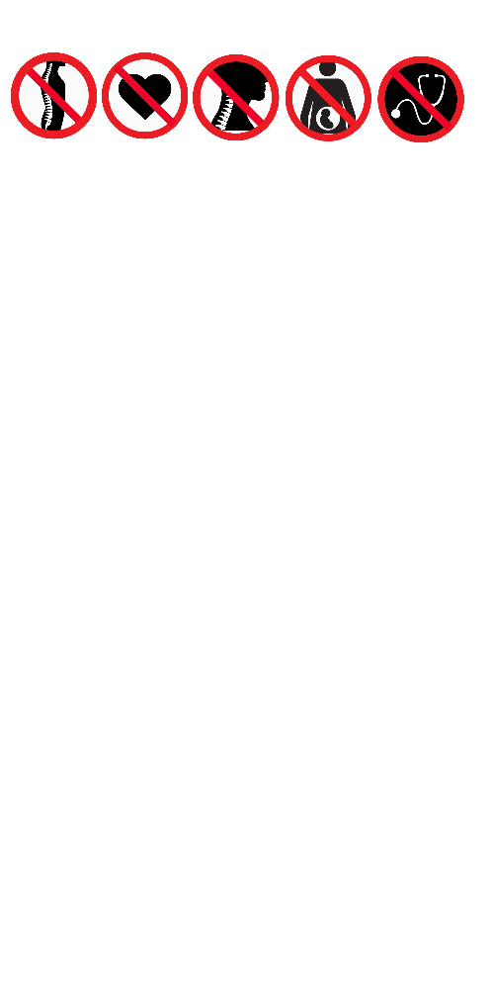 | Prohibited for Guests with back trouble.
 | Prohibited for Guests with heart trouble or high blood pressure.
 | Prohibited for Guests with neck trouble.
 | Prohibited for pregnant Guests.
 | Prohibited for Guests who have had recent surgery.

ACCESS SYMBOLS
Symbols indicate boarding procedures for each attraction and are defined below.
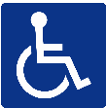 | This symbol is used to identify attractions where the Guest may remain in their wheelchair. (Castaway Creek, Suntan Lagoon, and Surf Lagoon)
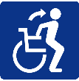 | This symbol identifies attractions that can accommodate Guests who are able to transfer from the wheelchair to the attraction unit by themselves or assisted by a member of their party.
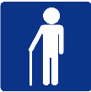 | This symbol identifies attractions where Guests must be able to walk independently or be assisted by a member of their party.

DEFINITIONS
Every attraction entrance lists height requirements and special instructions regarding the attraction. Six Flags Hurricane Harbor uses the following terms:

 | Ability to use one’s arms to maintain a grasp on an assist bar and support one’s body during normal and emergency procedures on an attraction and to use one’s legs to brace to maintain a seated position during the forces of the attraction.
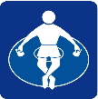 | Hand-held infants are children who are unable to independently walk or maintain seated postural control and will only be able to attraction the following attractions with a Supervising Companion: Castaway Creek, Suntan Lagoon and Surf Lagoon. Lifejackets are required in Castaway Creek and Suntan Lagoon.
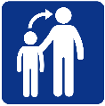 | A Supervising Companion is someone who meets all the requirements to attraction the attraction themselves, who is at least 54" in height, and demonstrates appropriate observed behavior. Supervising companions are responsible for ensuring that the accompanied rider remains seated properly where applicable and follows all rules and regulations. The supervising companion must be seated in the same seat (tube) as the rider who needs accompaniment and can accompany the number of riders for which the seat is designed. For example, if a seat is designed for three people, the supervising companion can accompany two riders.

HEALTH RESTRICTIONS
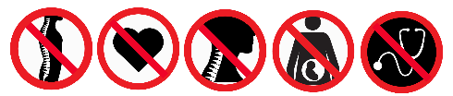
Each attraction is evaluated against 5 primary health restrictions. These restrictions are:
- Back Trouble
- Heart Trouble/High Blood Pressure
- Neck Trouble
- Pregnancy
- Recent Surgery
If you are in doubt about your ability to safely experience an attraction or would like more information, please review the information for each attraction in this Guest Accessibility Guide or review the Safety Guide and all warning signs posted at each attraction entrance and Alternate Access Entrances.

PREGNANCY
Guests who know or believe they may be pregnant should follow all rules, guidelines and restrictions listed for each attraction. Those who are pregnant should not participate on an attraction that specifically lists pregnancy as a rider restriction. Please closely review all rules and guidelines at the entrance of each attraction.

HEIGHT REQUIREMENTS
Height requirements and specific instructions are posted at the entrance to each attraction. Height stations are available throughout the pat.
To accurately measure Guests, a height measuring device may be used during the height measuring process. This device may come into contact with the Guest's head for a brief period.
For the safety of Guests, the height measuring process in the water park will require Guests to be bare foot.

LIFEJACKETS
Lifejackets are available for all Guests. Only U.S. Coast Guard approved lifejackets are allowed as flotation devices. Lifejackets are provided free of charge.
In Castaway Creek, a Lazy River, lifejackets are required for Guests who are less than 48" tall in bare feet, participants with a history of seizures (or similar medical conditions), heart conditions, or those who are inexperienced or non-swimmers. Guests who are less than 42" tall must wear lifejackets and be accompanied by supervising companions.
In Blue Raider, a tube slide, lifejackets are required for Guests who are less than 52" tall in bare feet, or those who are inexperienced or non-swimmers. Guests who are less than 42" tall must wear lifejackets and be accompanied by supervising companions.
In Raging Rapids, a tube slide, lifejackets are required for Guests who are less than 52" tall in bare feet, or those who are inexperienced or non-swimmers. Guests who are less than 42" tall must wear lifejackets and be accompanied by supervising companions.
In Surf Lagoon, a Wave Pool, lifejackets are required for Guests who are less than 52" tall in bare feet, participants with a history of seizures (or similar medical conditions), heart conditions, or those who are inexperienced or non-swimmers. Guests who are less than 42" tall must wear lifejackets and be accompanied by supervising companions.

CASTS & BRACES
Guests with casts and braces will be restricted from participating on attractions where the cast or brace will present a hazard to the Guest or others. Guests with full arm (elbow restricted) and full leg (knee restricted) casts or braces are restricted from most attractions and water slides. We suggest you delay your visit until the cast is removed. Casts and braces with exposed metal parts are not permitted on slides.

PROSTHETICS
Guests with prosthesis which do not have any exposed metal parts are generally permitted on all water park attractions.
The following chart displays the cast and brace rules for all attractions and attractions.

Y May ride/participate with the condition.  O Not permitted to participate on elevated activity area.  Z Participation or water depth may be restricted if necessary. | Cervical Collar or Neck Brace | Forearm Cast | Full Arm Cast | Braced Arm Cast | Foot or Lower Leg Cast | Full Leg Cast
Atlantic Panic – Body Slide
Banzai Pipeline – Body Slide
Blue Raider – Tube Slide
Caribbean Chaos – Body Slide
Castaway Creek – Lazy River |  | Z | Z | Z | Z | Z
Cowabunga – Tube Slide
Der Stuka – Body Slide
Dive Bomber – Body Slide
Geronimo – Body Slide
Hydramaniac – Body Slides
Jelly Fish Twist – Body Slide
Raging Rapids – Tube Slide
Rip Qurl – Tube Slide
Sea Wolf – Raft Slide
Shark Attack – Tube Slide
Shotgun Falls – Body Slides
Splash Island – Play Structure | O | O | O | O | O | O
Splashin' Seal – Body Slide
Stingray Racer – Body Slide
Suntan Lagoon – Activity Pool |  | Z | Z | Z | Z | Z
Surf Lagoon – Wave Pool |  | Z | Z | Z | Z | Z
Tornado – Tube Slide
Tsunami Surge – Tube Slide
Typhoon Twister – Tube Slide
Wahoo Racer – Mat Racer

ADDITIONAL INFORMATION
Our goal is to make Six Flags Hurricane Harbor as enjoyable and barrier-free as practical. Listed below are some of the services we offer. Please feel free to suggest areas in which we might improve in the future.
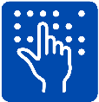 | Braille &Print Guides  Print versions of the Park Guide and Guest Accessibility Guide are available Guest Relations. Braille and large print versions are also available. There are a limited number of print guides which are obtainable on a first-come, first-served basis.
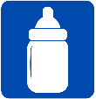 | Family Services  A space for nursing mothers is available at First Aid. Baby changing areas and a companion restroom can be found in most restrooms. Please feel free to ask a Team Member for directions to these locations or review a park map.
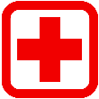 | First Aid  Our First Aid Station located at Geronimo and the Tornado is staffed from park open to park close. Medical equipment storage and refrigeration for Guests with medication is offered at First Aid.
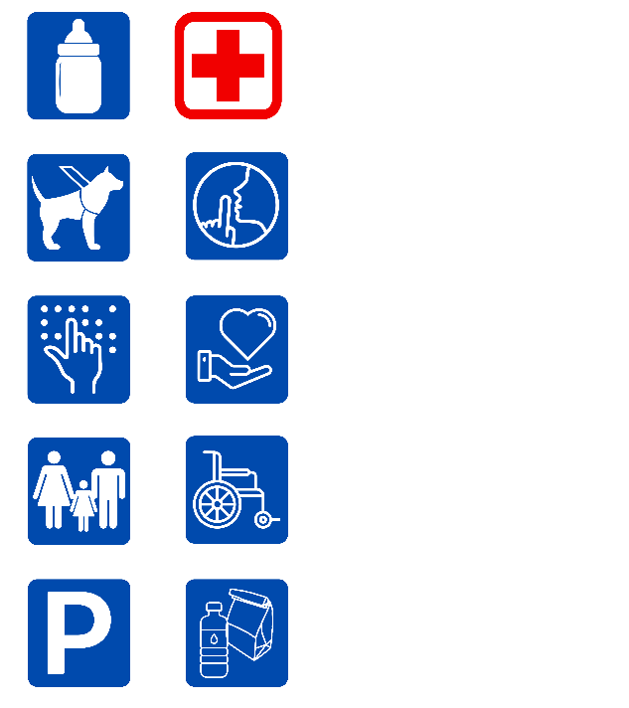 | Parking  Accessible parking is available on a first-come, first-serve basis within the main parking lots of the park. When you arrive at the parking toll booths, ask a Team Member for instructions regarding where to proceed to the accessible parking lot. Both auto and van accessible spaces are provided.  A valid disabled persons parking placard or license plate must be displayed at all times while parked in the designated accessible parking area. If the designated accessible parking area is full at the time of your arrival, members of your party may be dropped off at the main pick-up/drop-off area, near the main entrance to the park. Proper vehicle identification must be displayed.
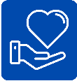 | Personal Care Giver  A Personal Care Giver is a guest who visits Six Flags Hurricane Harbor working in the capacity of a paid, formal, personal caregiver. A personal caregiver must be employed by an agency, group, or a family, and must be licensed or as described by local jurisdiction having authority.  A family member must meet the employment qualifications and provide acceptable documentation of a personal caregiver. To qualify for complimentary admission, the personal caregiver must initially provide acceptable documentation at Guest Services. If approved, the caregiver will be given a complimentary admission product that does not exceed the product held by the Guest in need of care. All available season pass add-on products may be purchased and added to the personal caregiver season pass.
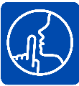 | Quiet Room  Six Flags Hurricane Harbor offers a Quiet Room located at First Aid, for family members or caregivers to take a break and reduce sensory stimulation.
Restrooms
Private restroom facilities for Guests needing the assistance of a companion are available at First Aid. Wheelchair accessible stalls are located at all restrooms.

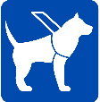 | Service Animals  Service animals are welcome at Six Flags Hurricane Harbor. A service animal is defined as a dog that has been individually trained to do work or perform tasks for a person with disabilities. Examples of such work or tasks include guiding people who are blind, alerting people who are deaf, pulling a wheelchair, alerting and protecting a person who is having a seizure, reminding a person with mental illness to take prescribed medications, calming a person with Post Traumatic Stress Disorder (PTSD) during an anxiety attack, or performing other duties. Service animals are working animals, not pets. The work or task a dog has been trained to provide must be directly related to the person’s disability. Dogs whose sole function is to provide comfort or emotional support do not qualify as service animals.  Service animals must be house broken, controlled with a restraining device, display appropriate behavior at all times while on our property. Guests whose service animal demonstrates aggressive and/or inappropriate actions toward a Guest or Team Member will be directed to remove the animal from the park. There is a limit of one service animal per Guest.  Due to the nature of most attractions, service animals must remain with a non-riding member of your party. We are not permitted to take control of your service animal. Service animals are not permitted in water attractions, wet decks, wading pools, or lazy rivers. Visit Guest Relations for more information.  A Service Animal “Relief Area” is located in the grassy area next to Banzai Pipeline. Owners are responsible for disposing of their animal’s waste.
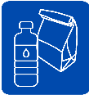 | Special Dietary Needs  Although outside food and beverages are not allowed in the park, individuals who have special diets or need items due to a medical condition may bring small coolers to accommodate such needs. Please visit Guest Services for more information.
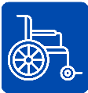 | Wheelchairs & Electric Convenience Vehicles  Guests who choose to use a wheelchair or ECV, we require a safe speed be maintained while traveling in the park.  On most attractions where Guests in wheelchairs can be accommodated, Guests will need to leave their wheelchairs to ascend the attraction tower and to be seated.  If in doubt about your ability to safely experience an attraction, we urge you to consult with our staff Guest Relations. Six Flags Hurricane Harbor personnel are not trained in transferring Guests from wheelchairs to attraction units and are not permitted to do so. You should plan your visit with someone who can physically help you when necessary.  While in the wave pool, the water level may not exceed the height of the seat on the chair. Guests participating in a wave pool are permitted to use a personal wheelchair. Personal wheelchairs are permitted up to the seat's water depth. Guests utilizing wheelchairs will not be required to utilize a lifejacket while in the wave pool only if their height exceeds 48”. While using a personal wheelchair, Guests must not utilize the wheelchair’s seatbelts while in the wave pool.  Motorized or electric personal wheelchairs will be permitted at Splash Island play structure (ground level) and the splash pad. Walkers, canes, or other assistive devices are permitted only at ankle depth in the following attractions: Surf Lagoon, Wave Pool, Splash Island (ground level) and the splash pad.

EVACUATIONS
Evacuations may be required due to mechanical reasons, weather conditions, or a power interruption. If an evacuation is required, Guests may be asked to evacuate pools as quickly as possible using stairs or ladders. If an evacuation from a slide is required, remain seated until given instructions. For safety reasons, we may evacuate ambulatory Guests prior to evacuating those Guests using wheelchairs. If so, you accept any risk due to delayed

GUESTS OF LARGER SIZE
Due to manufacturer requirements, Guests of a larger size (in terms of height, weight, and/or proportions) may not be accommodated on some of our attractions. Maximum [and minimum] weight limits can be found under the individual attractions in this guide and on the Rider Safety Guide signs at the entrance to attractions with restrictions.
Our larger Guests may experience difficulty on: Blue Raider, Rip Qurl, Sea Wolf, Shark Attack, Tornado, Tsunami Surge, and Typhoon Twister.
Scales are utilized on the following attractions: Blue Raider, Rip Qurl, Sea Wolf, Shark Attack, Tornado, Tsunami Surge, and Typhoon Twister.
The manufacturer requires a maximum Guest height on the following attractions: Splash Island Body Slides.

LOOSE ARTICLES
Most attractions cannot accommodate loose articles including jewelry, cell phones, hats, cameras, purses, backpacks, umbrellas, beverage containers, electronic devices, etc. Items must be safely secured in a locker, or with a non-rider. Six Flags Hurricane Harbor is not responsible for lost, stolen, or damaged items.
For safety reasons, cell phone usage, taking pictures and filming on attractions are prohibited. Glasses must be secured on all attractions. On Der Stuka, Dive Bomber, and Geronimo, glasses must be secured by an athletic strap or they cannot be worn on the attraction.
Hearing devices and other electronic devices may be damaged by water at water attractions and attractions. Please take necessary precautions to protect hearing devices on all attractions. Sensory headphones or helmets may be accommodated on select attractions.
Any non-compliance which results in damage or injury to a person or property will result in consequences up to and including prosecution.

LOST & FOUND
All items found at Six Flags Hurricane Harbor are turned in to Guest Relations. Items lost in a pool will not be retrieved until the end of the day. In order to keep the attraction in operation, an immediate search may not be possible. Lost articles may be reported via the internet at https://www.sixflags.com/lost-and-foud
FOR YOUR SAFETY, DO NOT ENTER UNAUTHORIZED AREAS TO RETRIEVE LOST ARTICLES. YOU CAN BE SERIOUSLY INJURED IF YOU ENTER AN UNAUTHORIZED AREA.

OXYGEN TANKS
Neither portable oxygen tanks nor personal oxygen equipment are permitted on waterpark attractions.

PROPER ATTIRE
Appropriate swimwear is required. Thongs and transparent clothing are not permitted. We reserve the right to determine the appropriateness of swimwear. Guests wearing bathing attire with metal buttons, rivets, zippers, or snaps will not be permitted to ride any of our slides. For your safety, loose clothing (including scarves and other free-flowing clothing) must be significantly secured or removed to prevent any interference with the ride experience. Hearing devices or other electronic devices may be damaged by water. Please take the necessary steps to protect such items. Contact lenses are not recommended. Guests requiring special accommodation should speak to a member of the Aquatics Supervisory Team.

SWIM DIAPERS
Guests who require a diaper are required to wear swim diapers or a diaper specifically designed for aquatic use.

SCALES
A red light/green light scale is used at this attraction. All riders will be weighed prior to riding. Guests who exceed the weight requirements will not be permitted to ride.
Maximum [and minimum] weight limits can be found under the individual attractions in this guide and on the Rider Safety Guide signs at the entrance to attractions with restrictions.
Scales are utilized on the following attractions: Blue Raider, Rip Qurl, Sea Wolf, Shark Attack, Tornado, Tsunami Surge, and Typhoon Twister.

ATTRACTION CRITERIA
Our Attraction Accessibility Program is designed to allow Guests to participate in the enjoyment of our attractions as much as possible. The program was developed by analyzing the physical and mental attributes required to safely participate on each attraction. It is our policy to allow anyone to participate who meets all these requirements and is not a hazard to themselves or others. We continue to evaluate and update our Attraction Accessibility Program as necessary.
The evaluation of each attraction considered the following criteria:
Independent seated postural.
The Guest must have the body and spinal control to sit upright without the aid of other people or devices. The Guest must also have sufficient muscle control to support their head, neck and upper torso during the course of the attraction, including the dynamic motion of the attraction.
Appropriate center of gravity.
The Guest’s body must have the appropriate weight distribution for that attraction.
Ability to hold on with one functioning arm.
Guests must have one functioning arm that exhibits good grip control, the ability to brace, and is strong enough to allow the Guest to maintain proper riding position throughout the duration of the attraction. A functioning arm may be a natural arm or a prosthesis which can be used for gripping and bracing. Any arm prosthesis must remain properly secured under the dynamic forces of the attraction. Due to manufacturer requirements, some attractions may exclude prosthetics.
Ability to hold on with two functioning arms.
Guests must have two functioning arms that exhibit good grip control, the ability to brace, and are strong enough to allow the Guest to maintain the proper riding position throughout the duration of the attraction. A functioning arm may be a natural arm or a prosthesis which can be used for gripping and bracing. Any arm prosthesis must remain properly secured under the dynamic forces of the attraction. Due to manufacturer requirements, some attractions may exclude prosthetics.
Ability to brace self with one functioning leg.
Guests must have one functioning leg to be used for bracing the body during the course of the attraction. A functioning leg may be a natural leg or a prosthesis used for bracing the body during the course of participation and maintaining balance when entering and exiting an attraction unit. Any leg prosthesis must remain properly secured under the dynamic forces of the attraction. Due to manufacturer requirements, some attractions may exclude prosthetics.
Ability to brace self with two functioning legs.
Guests must have two functioning legs to be used for bracing the body during the course of the attraction. A functioning leg may be a natural leg or a prosthesis used for bracing the body during the course of participation and maintaining balance when entering and exiting an attraction unit. Any leg prosthesis must remain properly secured under the dynamic forces of the attraction. Due to manufacturer requirements, some attractions may exclude prosthetics.
Minimum of two functioning extremities.
Guests must have a minimum of two functioning extremities (two legs, two arms, or one arm and one leg) to brace themselves during the attraction and assist in entering and exiting the attraction unit.
Minimum of three functioning extremities.
Guests must have a minimum of three functioning extremities (two legs and one arm or two arms and one leg) to brace themselves (with tripod bracing) during the attraction and assist in entering and exiting the attraction unit.
Minimum of four functioning extremities.
Guests must have four functioning extremities (two legs and two arms) to brace themselves during the attraction and assist in entering and exiting the attraction unit.
Ability to enter/exit attraction within specified parameters without endangering self or others.
Guests must be able to enter and exit the attraction without jeopardizing themselves or others and to assist with their own evacuation, if necessary. This may include special arrangements by having someone aid in boarding. For the safety of our Team Members and Guests, Team Members are instructed not to perform any lifting of Guests.
Appropriate observed behavior:
Guest demonstrates appropriate observed behavior indicating a willingness and ability to participate and/or follow Guest requirements. Appropriate observed behavior may include, but not be limited to maintaining proper riding position, attention and compliance to safety instructions, proper use of all attraction safety equipment and willingness to participate.
Guests have a duty to:
- Exercise good judgment
- Act in a responsible manner while using amusement attractions
- Not participate while under the influence of alcohol or drugs
- Properly use all attraction safety equipment provided

ONGOING LIFEGUARD TRAINING
In an ongoing effort to provide a safe and enjoyable water park experience for our Guests, Six Flags Hurricane Harbor routinely utilizes training exercises to improve our lifeguards’ skills and vigilance. These exercises will occur during normal operating hours and may consist of the following: submersible water manikins, the use of video surveillance equipment, internal and external audits, and active/inactive water rescues and/or first aid scenarios.

ATTRACTIONS
The following descriptions are designed to give you information on the type of actions caused by various attractions. Each of the following attractions will identify the restrictions according to the criteria itemized above.
In order to participate on most attractions, Guests must have seated postural control, appropriate center of gravity, appropriate observed behavior, and the ability to enter and exit the attraction safely.
Specific exceptions or qualifications to those four criteria will be noted in the information provided below. Please use caution when entering and exiting water park attractions as the surrounding areas may be slippery. Conveying devices such as tubes and rafts may be slippery and can shift during loading and unloading.

Atlantic Panic 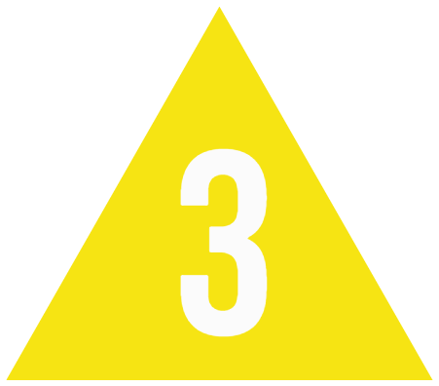
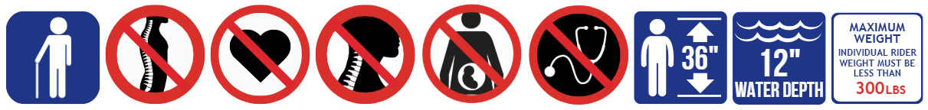

Guests must be 36" tall in bare feet to ride.
Maximum Individual Rider Weight – 300 lbs.
Hand-held infants are not permitted to ride slides.
Maximum one rider per slide.

Body slide with sudden drops designated for a single rider. Maximum water depth is 12 inches, finishing into a runout slide.
Attraction Criteria: Guests are required to maintain the proper riding position - slide on your back, feet first, arms crossed over the chest, legs straight, and ankles crossed. Do not attempt to slow yourself by grabbing or holding the side walls with either feet or hands. Guests must have two functioning arms and two functioning legs. Guests with a cervical collar, neck brace, broken collar bone, forearm casts, full arm casts, braced arm casts, foot or lower leg casts, full leg casts, are not permitted to ride.
Attraction Access: Access to the attraction requires climbing several flights of stairs. Riders will have to ascend the slide tower and be capable of safely entering the slide, on their own or with the assistance of a companion. To exit the slide, Guests must step out of the runout slide. Please use caution when entering and exiting as the area may be slippery.
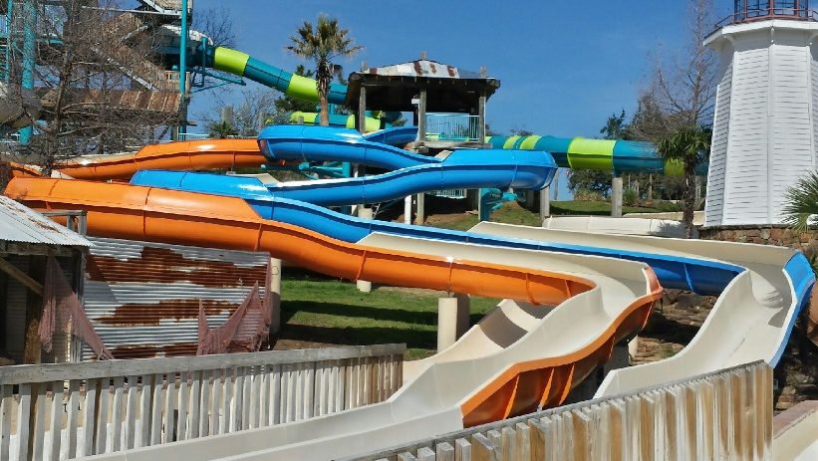

Banzai Pipeline
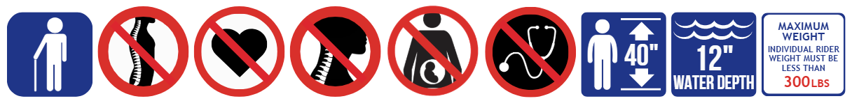
Guests must be 40" tall in bare feet to ride.
Maximum Individual Rider Weight – 300 lbs.
Hand-held infants are not permitted to ride slides.
Maximum one rider per slide.

Body slide with sudden drops designated for a single rider. Maximum water depth is 12 inches, finishing into a runout slide.
Attraction Criteria: Guests are required to maintain the proper riding position - slide on your back, feet first, arms crossed over the chest, legs straight, and ankles crossed. Do not attempt to slow yourself by grabbing or holding the side walls with either feet or hands.
Guests must have two functioning arms and two functioning legs. Guests with a cervical collar, neck brace, broken collar bone, forearm casts, full arm casts, braced arm casts, foot or lower leg casts, full leg casts, are not permitted to ride.
Attraction Access: Access to the attraction requires climbing several flights of stairs. Riders will have to ascend the slide tower and be capable of safely entering the slide, on their own or with the assistance of a companion. To exit the slide, Guests must step out of the runout slide. Please use caution when entering and exiting as the area may be slippery.
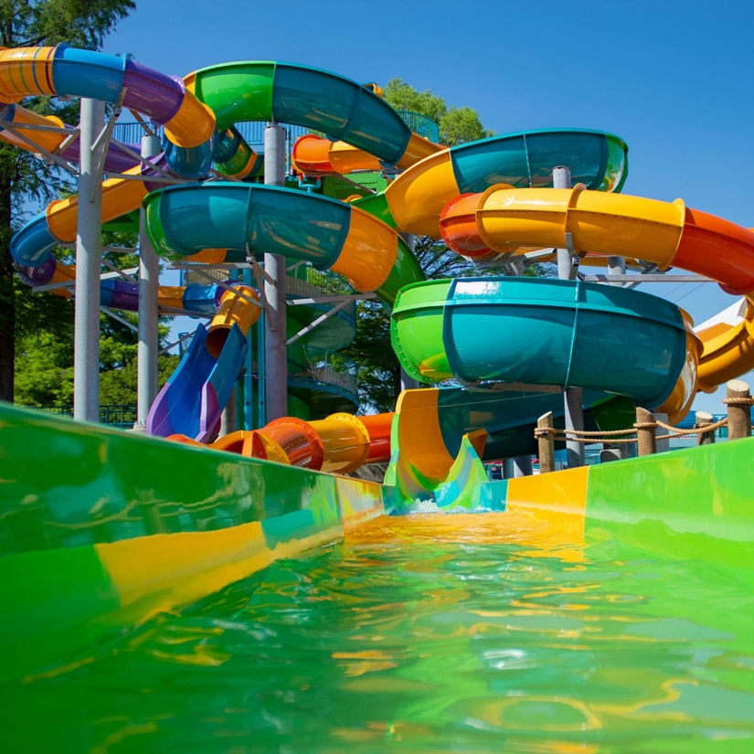

Blue Raider
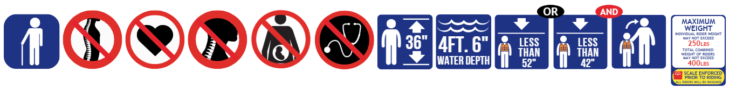
Guests must be 36" tall in bare feet to ride. Guests under 48" tall in bare feet and/or those who are inexperienced or non-swimmers are required to wear a lifejacket. Guests under 42” tall in bare feet must be accompanied by a supervising companion.

Maximum Individual Rider Weight – 250 lbs.
Maximum Combined Riders Weight – 400 lbs.
Hand-held infants are not permitted to ride slides.
Minimum one rider; maximum two riders.
A moderate tube slide that takes riders through both open-air and darkened enclosed flumes with movements from side-to-side before finishing in a splash pool. Maximum water depth is 4 feet 6 inches.
Attraction Criteria: Guests are required to maintain the proper riding position. Single riders must sit in the back of the double tube. Double riders in a double tube must sit with the heavier rider in the back. Riders must sit facing forward in the direction of travel and hold onto the handles. Front rider sits between the legs of the heavier rider. Back rider sits with legs straddling the front rider if riding as double riders. Back rider sits with legs over the middle of the tube if riding as a single rider. Do not rock, stop or slow your tube. Guests must have a minimum of three functioning extremities: two functioning arms and one functioning leg. Guests with a cervical collar, neck brace, broken collar bone, forearm casts, full arm casts, braced arm casts, foot or lower leg casts, full leg casts, are not permitted to ride.
Attraction Access: Access to the attraction requires climbing several flights of stairs with a tube. Riders will have to ascend the slide tower and be capable of safely entering the slide, on their own or with the assistance of a companion. Please use caution when entering and exiting as the tube may shift. To exit the pool, riders must utilize stairs to exit. The tube and surrounding area may also be slippery.
Scale Enforcement: A red light/green light scale is used at this attraction. All riders will be weighed prior to riding. Guests who exceed the weight requirements will not be permitted to ride.
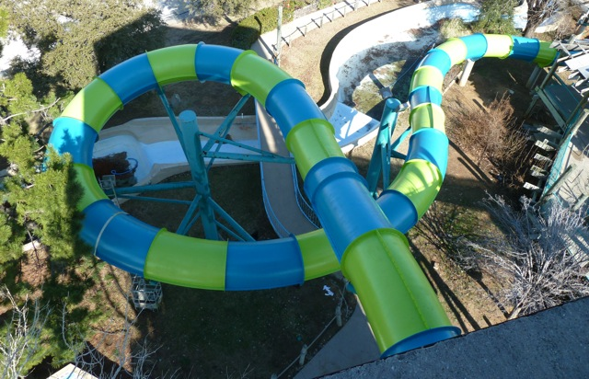
Caribbean Chaos

Guests must be 36" tall in bare feet to ride.
Maximum Individual Rider Weight – 300 lbs.
Hand-held infants are not permitted to ride slides.
Maximum one rider per slide.

Body slide with sudden drops designated for a single rider. Maximum water depth is 12 inches, finishing into a runout slide.
Attraction Criteria: Guests are required to maintain the proper riding position - slide on your back, feet first, arms crossed over the chest, legs straight, and ankles crossed. Do not attempt to slow yourself by grabbing or holding the side walls with either feet or hands. Guests must have two functioning arms and two functioning legs. Guests with a cervical collar, neck brace, broken collar bone, forearm casts, full arm casts, braced arm casts, foot or lower leg casts, full leg casts, are not permitted to ride.
Attraction Access: Access to the attraction requires climbing several flights of stairs. Riders will have to ascend the slide tower and be capable of safely entering the slide, on their own or with the assistance of a companion. To exit the slide, Guests must step out of the runout slide. Please use caution when entering and exiting as the area may be slippery.

Castaway Creek 
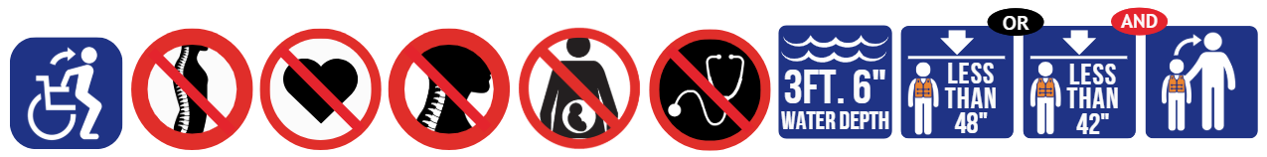

Guests under 48" tall in bare feet and/or those who are inexperienced or non-swimmers are required to wear a lifejacket. Guests under 42” tall in bare feet must be accompanied by a supervising companion.
Hand-held infants must be accompanied by a supervising companion.
A supervising companion may accompany up to 2 Guests.

A slow-moving, winding river where Guests may float with or without tubes. Maximum water depth is 3 feet 6 inches.
Attraction Criteria: Guests must be able to maintain independent seated postural control and must have appropriate observed behavior or be accompanied by a supervising companion. Guests who cannot enter/exit without endangering self or others must be accompanied by a supervising companion. Hand-held infants must be accompanied by a supervising companion. Guests with a forearm casts, full arm cast, braced arm casts, foot or lower leg casts, and full leg casts, are welcome to enjoy the attraction, but participation or water depth may be restricted if necessary. Guests with a cervical collar, neck brace, broken collar bone, are not permitted to participate.
Attraction Access: Access is available via the ramp or stairs. Riders will have to transfer to the ramp, stairs, or tube, on their own or with the assistance of a companion. Wheelchairs are permitted in the ramp for transfer but are not permitted in the river. Please use caution when entering and exiting as the area may be slippery.
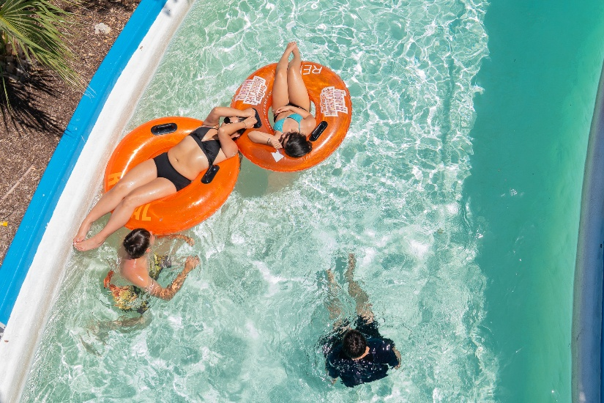

Cowabunga

Guests of walking age to 42” tall must ride with a supervising companion. Guests must be 42" tall in bare feet to ride alone. Guests over 54” tall must be accompanying a Guests under 42” tall.
Hand-held infants are not permitted to ride slides.
Maximum two riders per slide.
Small children's body slide. Maximum water depth is 6 inches.
Attraction Criteria: Guests are required to maintain the proper riding position. Rider must remain in an upright, feet first, seated position. Rider must ride beside their supervisor companion in the next lane. Lap riders are not permitted. Do not attempt to slow yourself by grabbing or holding the sidewalls with your hands or feet. Hand-held infants are not permitted to ride slides. Guests must have two functioning arms and two functioning legs. Guests with a cervical collar, neck brace, broken collar bone, forearm casts, full arm casts, braced arm casts, foot or lower leg casts, full leg casts, are not permitted to ride.
Attraction Access: Access to the attraction requires climbing of stairs. Riders will have to ascend the slide tower and be capable of safely entering the slide, on their own or with the assistance of a companion. To exit the slide, Guests must step out of the runout slide. Please use caution when entering and exiting as the area may be slippery.
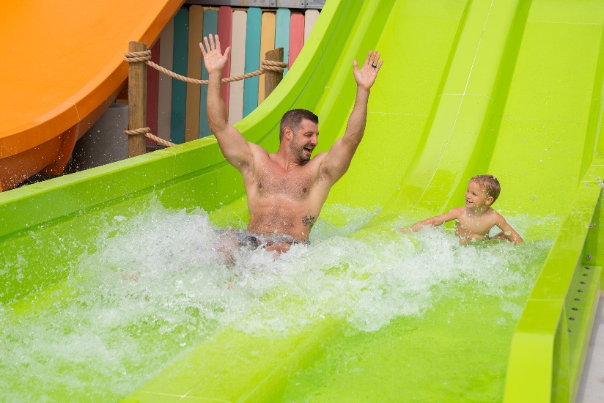

Der Stuka 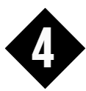
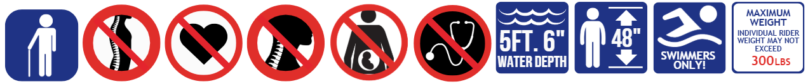

Guests must be 48" tall in bare feet to ride.
Maximum Individual Rider Weight – 300 lbs.
Hand-held infants are not permitted to ride slides.
Maximum one rider per slide.

High speed body slide with a sudden drop designated for a single rider. Maximum water depth is 5 feet 6 inches.
Attraction Criteria: Guests are required to maintain the proper riding position – slide on your back, feet first, with hands behind the head, legs straight and ankles crossed. Do not attempt to slow yourself by grabbing or holding the side walls with either feet or hands. Guests must have two functioning arms and two functioning legs. Guests with a cervical collar, neck brace, broken collar bone, forearm casts, full arm casts, braced arm casts, foot or lower leg casts, full leg casts, are not permitted to ride.
Attraction Access: Access to the attraction requires climbing several flights of stairs. Riders will have to ascend the slide tower and be capable of safely entering the slide, on their own or with the assistance of a companion. To exit the pool, riders must utilize a ladder or stairs to exit. Please use caution when entering and exiting as the area may be slippery.
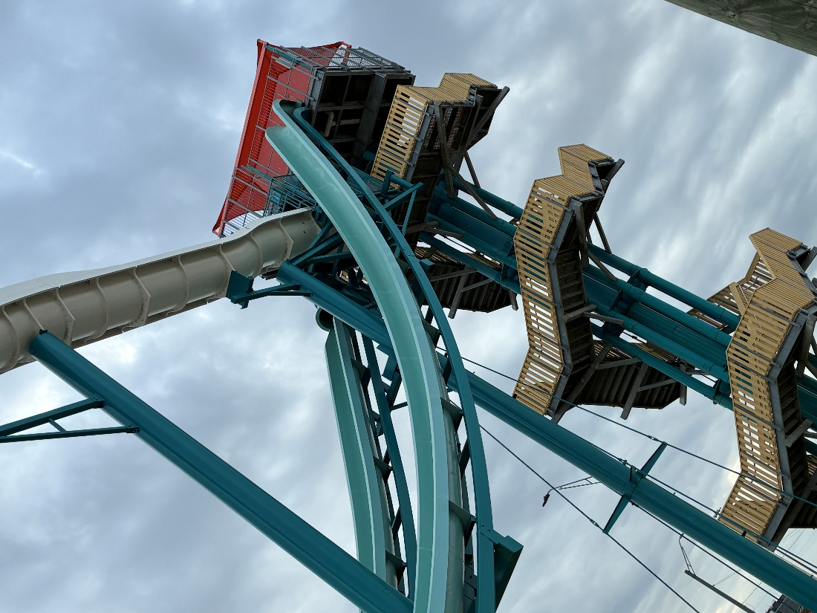
Dive Bomber

Guests must be 48" tall in bare feet to ride.
Maximum Individual Rider Weight – 300 lbs.
Hand-held infants are not permitted to ride slides.
Maximum one rider per slide.

High speed body slide with a sudden drop designated for a single rider. Maximum water depth is 5 feet 6 inches.
Attraction Criteria: Guests are required to maintain the proper riding position – slide on your back, feet first, with hands behind the head, legs straight and ankles crossed. Do not attempt to slow yourself by grabbing or holding the side walls with either feet or hands. Guests must have two functioning arms and two functioning legs. Guests with a cervical collar, neck brace, broken collar bone, forearm casts, full arm casts, braced arm casts, foot or lower leg casts, full leg casts, are not permitted to ride.
Attraction Access: Access to the attraction requires climbing several flights of stairs. Riders will have to ascend the slide tower and be capable of safely entering the slide, on their own or with the assistance of a companion. To exit the pool, riders must utilize a ladder or stairs to exit. Please use caution when entering and exiting as the area may be slippery.
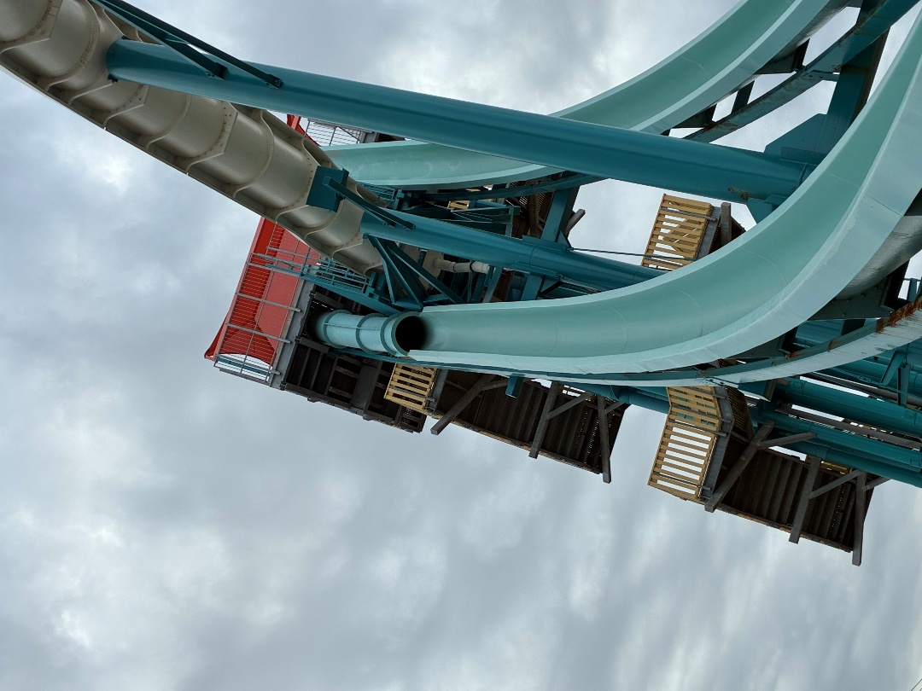

Geronimo

Guests must be 48" tall in bare feet to ride.
Maximum Individual Rider Weight – 300 lbs.
Hand-held infants are not permitted to ride slides.
Maximum one rider per slide.

High speed body slide with a sudden drop designated for a single rider. Maximum water depth is 5 feet 6 inches.
Attraction Criteria: Guests are required to maintain the proper riding position – slide on your back, feet first, with hands behind the head and, legs straight and ankles crossed. Do not attempt to slow yourself by grabbing or holding the side walls with either feet or hands. Guests must have two functioning arms and two functioning legs. Guests with a cervical collar, neck brace, broken collar bone, forearm casts, full arm casts, braced arm casts, foot or lower leg casts, full leg casts, are not permitted to ride.
Attraction Access: Access to the attraction requires climbing several flights of stairs. Riders will have to ascend the slide tower and be capable of safely entering the slide, on their own or with the assistance of a companion. To exit the pool, riders must utilize a ladder or stairs to exit. Please use caution when entering and exiting as the area may be slippery.
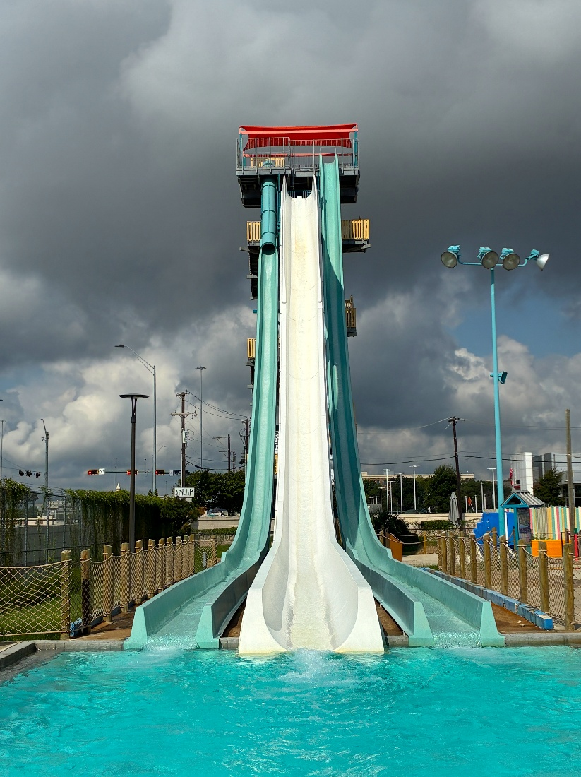
Hydramaniac 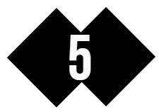
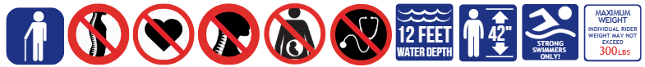

Guests must be 42" tall in bare feet to ride.
Maximum Individual Rider Weight – 300 lbs.
Hand-held infants are not permitted to ride slides.
Maximum one rider per slide.

High speed body slide with a 6-foot drop into the catch pool and strong water current. Designated for a single rider. Maximum water depth is 12 feet.
WARNING: STRONG SWIMMERS ONLY.
Attraction Criteria: Guests are required to maintain the proper riding position - slide on your back, feet first, with hands behind the head, legs straight and ankles crossed. Do not attempt to slow yourself by grabbing or holding the side walls with either feet or hands. Guests must have two functioning arms and two functioning legs. Guests with a cervical collar, neck brace, broken collar bone, forearm casts, full arm casts, braced arm casts, foot or lower leg casts, full leg casts, are not permitted to ride.
Attraction Access: Access to the attraction requires climbing several flights of stairs. Riders will have to ascend the slide tower and be capable of safely entering the slide, on their own or with the assistance of a companion. To exit the pool, riders must utilize a ladder to exit. Please use caution when entering and exiting as the area may be slippery.
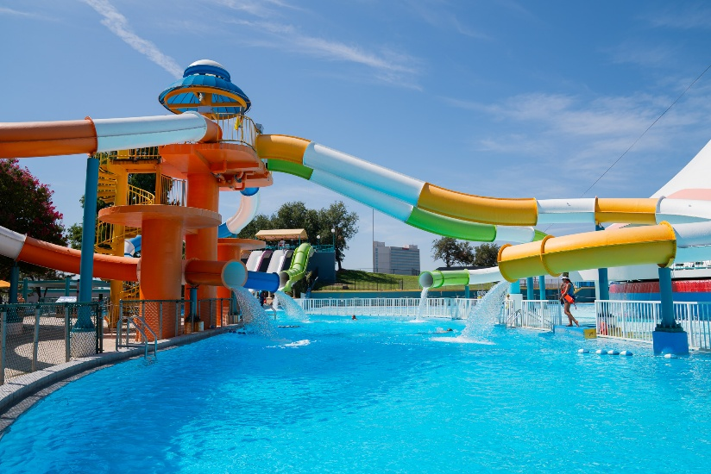

Jelly Fish Twist
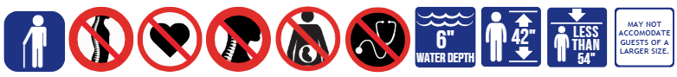
Guests must be between 42” - 54" tall in bare feet to ride.
Hand-held infants are not permitted to ride slides.
Maximum one rider per slide.

Small children's body slide. Maximum water depth is 6 inches.
Attraction Criteria: Guests are required to maintain the proper riding position – slide on your back, feet first, with hands behind the head, legs straight and ankles crossed. Do not attempt to slow yourself by grabbing or holding the side walls with either feet or hands. Guests must have two functioning arms and two functioning legs. Guests with a cervical collar, neck brace, broken collar bone, forearm casts, full arm casts, braced arm casts, foot or lower leg casts, full leg casts, are not permitted to ride.
Attraction Access: Access to the attraction requires climbing of stairs. Riders will have to ascend the slide tower and be capable of safely entering the slide, on their own or with the assistance of a companion. To exit the slide, Guests must step out of the runout slide. Please use caution when entering and exiting as the area may be slippery.
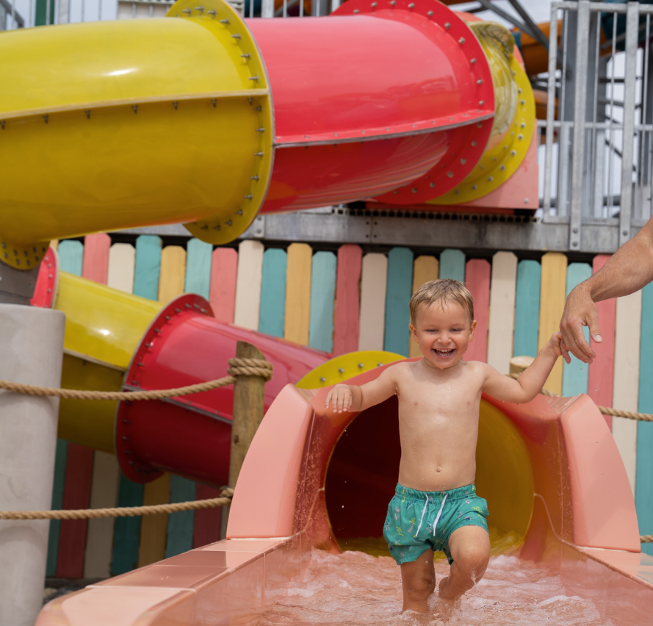

Raging Rapids

Guests must be 36" tall in bare feet to ride. Guests under 52" tall in bare feet and/or those who are inexperienced or non-swimmers are required to wear a lifejacket. Guests under 42” tall in bare feet must be accompanied by a supervising companion.

Maximum Individual Rider Weight – 250 lbs.
Hand-held infants are not permitted to ride slides.
Maximum one rider per tube.

A moderate experience where riders will travel down a path of gentle pools with rapid movements from side-to-side before finishing in a splash pool. Maximum water depth is 4 feet 6 inches.
Attraction Criteria: Guests are required to maintain the proper riding position - Guests must remain seated in the tube facing forward, holding onto the handles with legs extended forward throughout the ride. Guests must have a minimum of three functioning extremities: two functioning arms and one functioning leg. Guests with a cervical collar, neck brace, broken collar bone, forearm casts, full arm casts, braced arm casts, foot or lower leg casts, full leg casts, are not permitted to ride.
Attraction Access: Access to the attraction requires climbing several flights of stairs with a tube. Riders will have to ascend the slide tower and be capable of safely entering the slide, on their own or with the assistance of a companion. Please use caution when entering and exiting as the tube may shift. To exit the pool, riders must utilize stairs to exit. The tube and surrounding area may also be slippery.
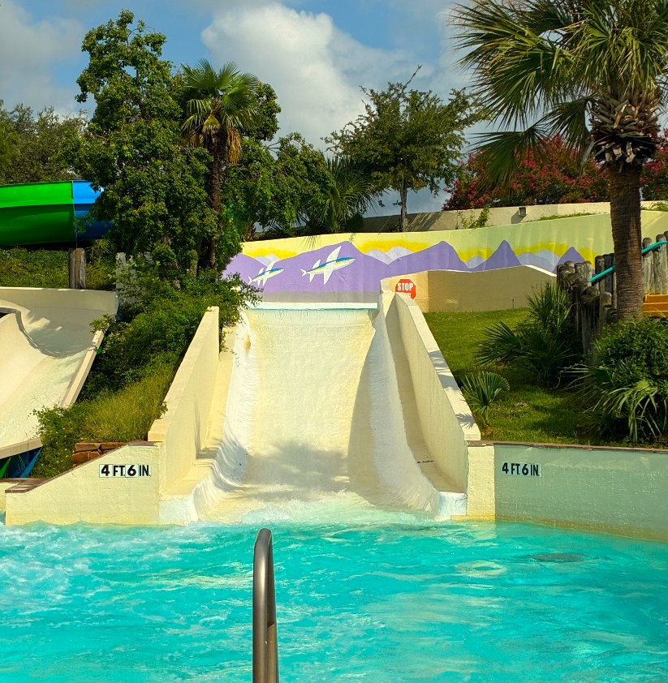

Rip Qurl
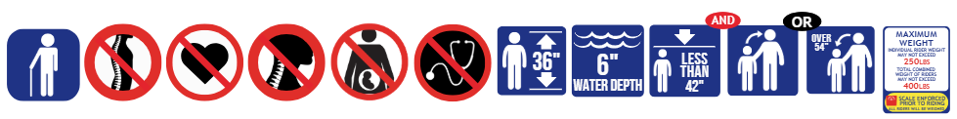
Guests must be 36" tall in bare feet to ride. Guests under 42” tall in bare feet must be accompanied by a supervising companion. Guests must be 42” tall to ride alone.

Maximum Individual Rider Weight – 250 lbs.
Maximum Combined Riders Weight – 400 lbs.
Hand-held infants are not permitted to ride slides.
Minimum one rider; maximum two riders.

A moderate tube slide that takes riders through both open-air and darkened enclosed flumes, along with oscillating funnel. Once momentum subsides, the ride continues onwards before finishing in a runout slide. Riders will experience weightlessness, and moderately changing forces and direction. Maximum water depth is 6 inches.
Attraction Criteria: Guests are required to maintain the proper riding position. Single riders less than 54” tall must ride in a single tube. Double riders in a double tube must sit with the heavier rider in the back. Riders must sit facing forward in the direction of travel and hold onto the handles. Front rider sits between the legs of the heavier rider. Back rider sits with legs straddling the front rider if riding as double riders. Back rider sits with legs over the middle of the tube if riding as a single rider. Do not rock, stop or slow your tube. Guests must have a minimum of three functioning extremities: two functioning arms and one functioning leg. Guests with a cervical collar, neck brace, broken collar bone, forearm casts, full arm casts, braced arm casts, foot or lower leg casts, full leg casts, are not permitted to ride.
Attraction Access: Access to the attraction requires climbing stairs with a tube. Riders will have to ascend the slide tower and be capable of safely entering the slide, on their own or with the assistance of a companion. Please use caution when entering and exiting as the tube may shift. To exit the slide, Guests must step out of the runout slide. The tube and surrounding area may also be slippery.
Scale Enforcement: A red light/green light scale is used at this attraction. All riders will be weighed prior to riding. Guests who exceed the weight requirements will not be permitted to ride.
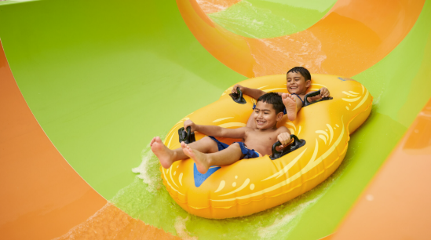
Sea Wolf
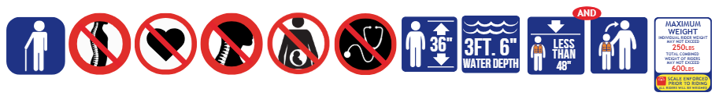
Guests must be 36" tall in bare feet to ride. Guests between 36”-48” tall in bare feet must wear a lifejacket and be accompanied by a supervising companion.
Maximum Individual Rider Weight – 250 lbs.
Maximum Combined Riders Weight – 600 lbs.
Hand-held infants are not permitted to ride slides.
Minimum two riders; maximum three riders.

A moderate raft slide that takes riders down a path of variable speeds, multi-directional forces, and steep drops, which may include free-falling sensations. Once momentum subsides, the ride continues onwards before finishing in splash pool. Maximum water depth is 3 feet 6 inches.
Attraction Criteria: Guests are required to maintain the proper riding position. Riders must be seated with the lightest rider in front and the heavier rider in the back. Front rider will cross their legs, the middle and back rider will straddle the rider in front. Riders must sit up, facing forward and hold onto the handles. Do not rock, stop or slow your raft. Guests must have a minimum of three functioning extremities: two functioning arms and one functioning leg. Guests with a cervical collar, neck brace, broken collar bone, forearm casts, full arm casts, braced arm casts, foot or lower leg casts, full leg casts, are not permitted to ride.
Attraction Access: Access to the attraction requires climbing several flights of stairs. Riders will have to ascend the slide tower and be capable of safely entering the raft, on their own or with the assistance of a companion. Please use caution when entering and exiting as the raft may shift. To exit the pool, riders must utilize stairs to exit. The raft and surrounding area may also be slippery.
Scale Enforcement: A red light/green light scale is used at this attraction. All riders will be weighed prior to riding. Guests who exceed the weight requirements will not be permitted to ride.
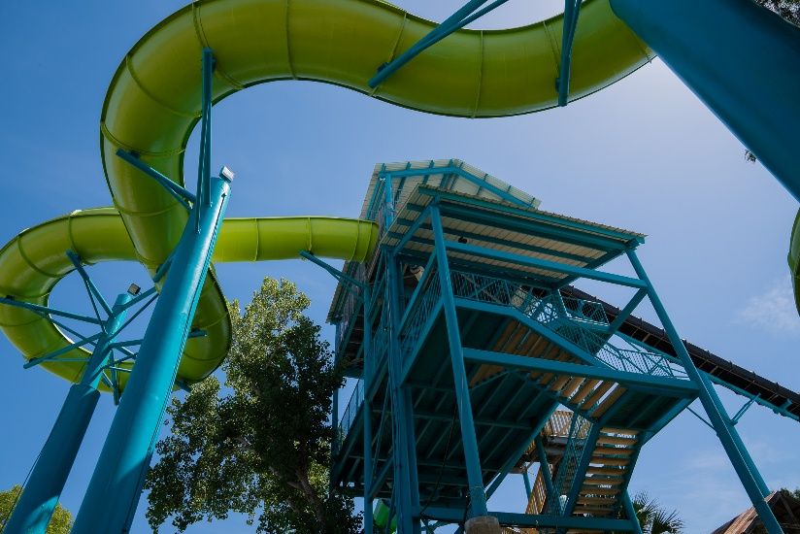

Shark Attack
Guests must be 36" tall in bare feet to ride. Guests under 42” tall in bare feet must be accompanied by a supervising companion. Guests must be 42” tall to ride alone.

Maximum Individual Rider Weight – 250 lbs.
Maximum Combined Riders Weight – 400 lbs.
Hand-held infants are not permitted to ride slides.
Minimum one rider; maximum two riders.

A moderate tube slide where riders descend down a darkened enclosed flume before exiting into an open-air half-pipe wave. The tube will slide back and forth in the slide before finally ending in a runout slide. Riders will experience weightlessness, and moderately changing forces and direction. Maximum water depth is 6 inches.
Attraction Criteria: Guests are required to maintain the proper riding position. Single riders less than 54” tall must ride in a single tube. Double riders in a double tube must sit with the heavier rider in the back. Riders must sit facing forward in the direction of travel and hold onto the handles. Front rider sits between the legs of the heavier rider. Back rider sits with legs straddling the front rider if riding as double riders. Back rider sits with legs over the middle of the tube if riding as a single rider. Do not rock, stop or slow your tube. Guests must have a minimum of three functioning extremities: two functioning arms and one functioning leg. Guests with a cervical collar, neck brace, broken collar bone, forearm casts, full arm casts, braced arm casts, foot or lower leg casts, full leg casts, are not permitted to ride.
Attraction Access: Access to the attraction requires climbing stairs with a tube. Riders will have to ascend the slide tower and be capable of safely entering the slide, on their own or with the assistance of a companion. Please use caution when entering and exiting as the tube may shift. To exit the slide, Guests must step out of the runout slide. The tube and surrounding area may also be slippery.
Scale Enforcement: A red light/green light scale is used at this attraction. All riders will be weighed prior to riding. Guests who exceed the weight requirements will not be permitted to ride.
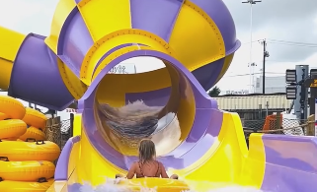
Shotgun Falls

Guests must be 42" tall in bare feet to ride.
Maximum Individual Rider Weight – 300 lbs.
Hand-held infants are not permitted to ride slides.
Maximum one rider per slide.

High speed body slide with a 6-foot drop into the catch pool and strong water current. Designated for a single rider. Maximum water depth is 12 feet.
WARNING: STRONG SWIMMERS ONLY.
Attraction Criteria: Guests are required to maintain the proper riding position - slide on your back, feet first, with hands behind the head, legs straight and ankles crossed. Do not attempt to slow yourself by grabbing or holding the side walls with either feet or hands. Guests must have two functioning arms and two functioning legs. Guests with a cervical collar, neck brace, broken collar bone, forearm casts, full arm casts, braced arm casts, foot or lower leg casts, full leg casts, are not permitted to ride.
Attraction Access: Access to the attraction requires climbing several flights of stairs. Riders will have to ascend the slide tower and be capable of safely entering the slide, on their own or with the assistance of a companion. To exit the pool, riders must utilize a ladder to exit. Please use caution when entering and exiting as the area may be slippery.
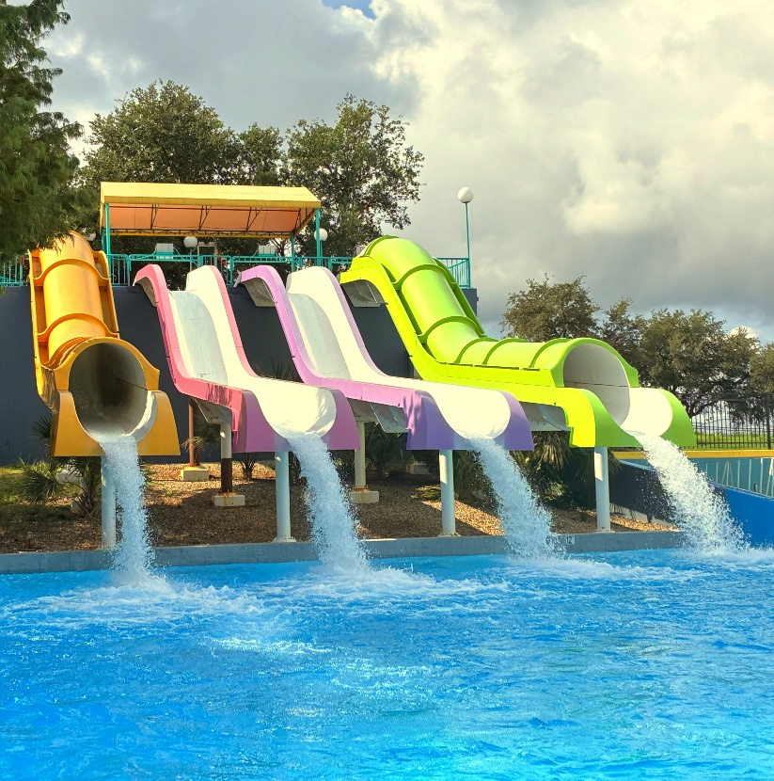

Splash Island – Play Structure
Guests under 40" tall or under 6 years old should be accompanied by a supervising companion and wear a lifejacket.
Guests must be 36” tall in bare feet to ride the body slides.
Guests must be between 36”-54” in bare feet to ride the teal and orange body slides.
Hand-held infants are not permitted to ride slides and must remain on ground level with a supervising companion.

A multi-level interactive water play structure with various play elements, water sprayers, and two drenching buckets that dump water every few minutes. Maximum water depth is less than 6 inches on and around the structure.
Attraction Criteria for Body Slides: Guests are required to maintain the proper riding position – slide on your back, feet first, with hands behind the head, legs straight and ankles crossed. Do not attempt to slow yourself by grabbing or holding the side walls with either feet or hands. Guests must have two functioning arms and two functioning legs. Guests with a cervical collar, neck brace, broken collar bone, forearm casts, full arm casts, braced arm casts, foot or lower leg casts, full leg casts, are not permitted to ride.
Attraction Criteria for Play Structure: Guests with a cervical collar, neck brace or broken collar bone are not permitted to participate on the elevated activity areas of this attraction. Guests unable to maintain seated postural control must be accompanied by a supervising companion. Hand-held infants must remain on ground level with a supervising companion.
Attraction Access: This attraction is wheelchair accessible on the ground level. Access to the elevated levels requires Guests to climb several flights of stairs. Guests will have to ascend the slide tower and be capable of safely entering the slide, on their own or with the assistance of a companion. To exit the slide, Guests must step out of the runout slide. Please use caution when entering and exiting as the area may be slippery.

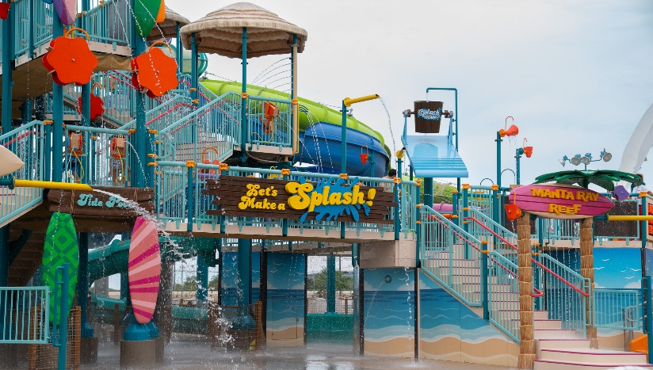

Splashin’ Seal

Guests of walking age to 42” tall must ride with a supervising companion.
Guests must be 42" tall in bare feet to ride alone.
Guests over 54” tall must be accompanying a Guests under 42” tall.
Hand-held infants are not permitted to ride slides.
Maximum two riders per slide.
Small children's body slide. Maximum water depth is 6 inches.
Attraction Criteria: Guests are required to maintain the proper riding position. Rider must remain in an upright, feet first, seated position. Rider must ride beside their supervisor companion. Lap riders are not permitted. Do not attempt to slow yourself by grabbing or holding the sidewalls with your hands or feet. Hand-held infants are not permitted to ride slides. Guests must have two functioning arms and two functioning legs. Guests with a cervical collar, neck brace, broken collar bone, forearm casts, full arm casts, braced arm casts, foot or lower leg casts, full leg casts, are not permitted to ride.
Attraction Access: Access to the attraction requires climbing of stairs. Riders will have to ascend the slide tower and be capable of safely entering the slide, on their own or with the assistance of a companion. To exit the slide, Guests must step out of the runout slide. Please use caution when entering and exiting as the area may be slippery.
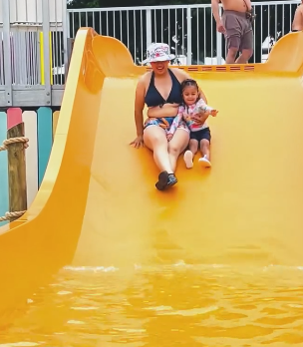

Stingray Racer

Guests of walking age to 42” tall must ride with a supervising companion.
Guests must be 42" tall in bare feet to ride alone.
Guests over 54” tall must be accompanying a Guests under 42” tall.
Hand-held infants are not permitted to ride slides.
Maximum two riders per slide.
Small children's body slide. Maximum water depth is 6 inches.
Attraction Criteria: Guests are required to maintain the proper riding position. Rider must remain in an upright, feet first, seated position. Rider must ride beside their supervisor companion in the next lane. Lap riders are not permitted. Do not attempt to slow yourself by grabbing or holding the sidewalls with your hands or feet. Hand-held infants are not permitted to ride slides. Guests must have two functioning arms and two functioning legs. Guests with a cervical collar, neck brace, broken collar bone, forearm casts, full arm casts, braced arm casts, foot or lower leg casts, full leg casts, are not permitted to ride.
Attraction Access: Access to the attraction requires climbing of stairs. Riders will have to ascend the slide tower and be capable of safely entering the slide, on their own or with the assistance of a companion. To exit the slide, Guests must step out of the runout slide. Please use caution when entering and exiting as the area may be slippery.
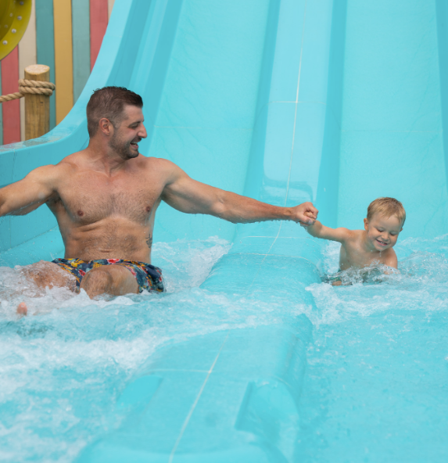

Suntan Lagoon 
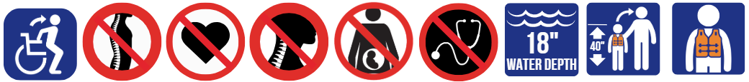
Guests under 40" tall or under 6 years old should be accompanied by a supervising companion and wear a lifejacket. Weak and non-swimmers are encouraged to wear a lifejacket.
Hand-held infants must be accompanied by a supervising companion.
A family pool for swimming and wading with water elements and features. Maximum water depth is 18 inches.
Attraction Criteria: Guests must be able to safely enter/exit the attraction and demonstrate appropriate observed behavior or be accompanied by a supervising companion. Hand-held infants must be accompanied by a supervising companion. Guests with a forearm cast, full arm cast, braced arm cast, foot or lower leg casts, and full leg casts, are welcome to enjoy the attraction, but participation or water depth may be restricted if necessary. Guests with a cervical collar, neck brace, broken collar bone, are not permitted to participate.
Attraction Access: Access is available via ramp. This pool is wheelchair accessible, although the water level may not exceed the height of the seat on the chair. If the wheelchair includes a seatbelt, the seat belt may not be fastened when in the pool. Please use caution when entering and exiting as the area may be slippery.
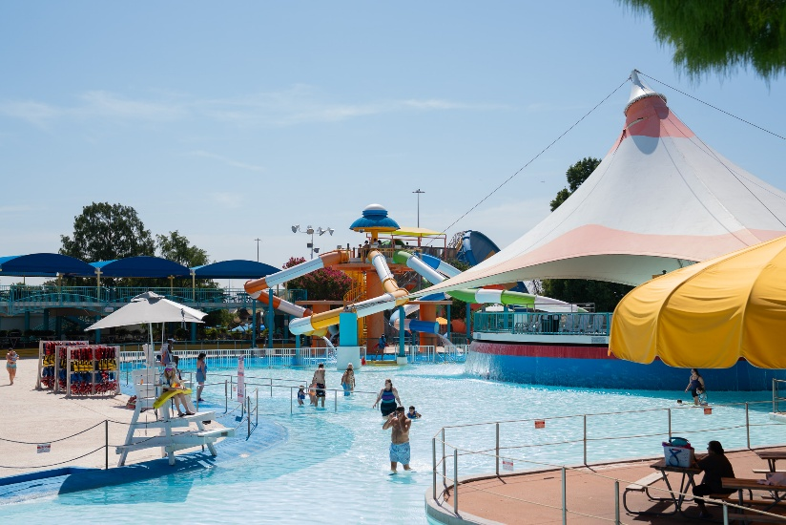

Surf Lagoon
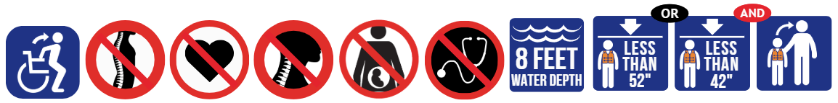
Guests under 52" tall in bare feet and/or those who are inexperienced or non-swimmers are required to wear a lifejacket.
Guests under 42” tall in bare feet must be accompanied by a supervising companion. A supervising companion may accompany up to 2 Guests.
Hand-held infants must be accompanied by a supervising companion and are only permitted in the shallow end.

A large wave pool with depths ranging from 0 feet to 8 feet. Waves are generated for 5 minutes on, and then 5 minutes off. Strenuous activity is required during wave action cycles which may require the ability to swim and which may result in fatigue. Exercise Caution. Participants with a history of seizures-or heart or other serious medical conditions-should be supervised by someone who knows how to swim and how to provide emergency assistance. Maximum water depth is 8 feet.
WARNING: ONLY STRONG SWIMMERS ARE RECOMMENDED PASSED THE RED LINE AND IN DEEP WATER.
Attraction Criteria: Guests must be able to safely enter/exit the attraction and demonstrate appropriate observed behavior or be accompanied by a supervising companion. Hand-held infants must be accompanied by a supervising companion. Guests with a forearm cast, full arm cast, braced arm cast, foot or lower leg casts, and full leg casts, are welcome to enjoy the attraction, but participation or water depth may be restricted if necessary. Guests with a cervical collar, neck brace, broken collar bone, are not permitted to participate.
Attraction Access: Access is available via the zero-depth entry and ladders. This attraction is wheelchair accessible, although the water level may not exceed the height of the seat on the chair. If the wheelchair includes a seatbelt, the seat belt may not be fastened when in the pool. Please use caution when entering and exiting as the area may be slippery.
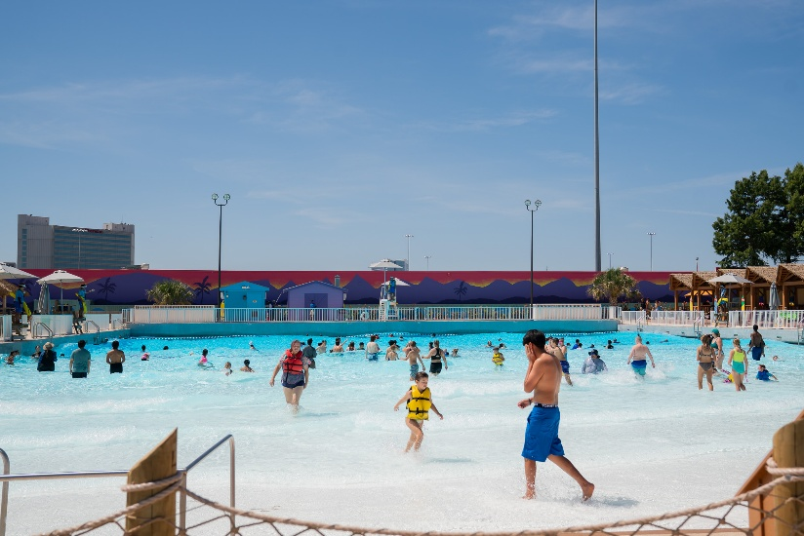

Tornado
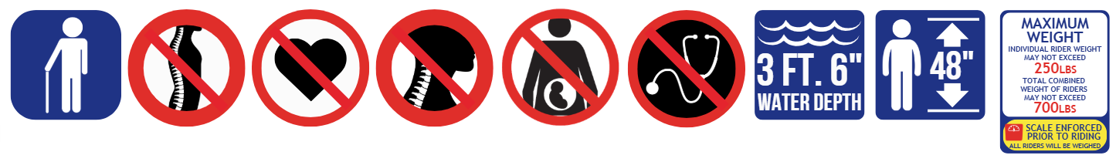
Guests must be 48" tall in bare feet to ride.
Maximum Individual Rider Weight – 250 lbs.
Maximum Combined Riders Weight – 700 lbs.
Hand-held infants are not permitted to ride slides.
Minimum two riders; maximum four riders.

A thrilling tube slide takes riders twisting and turning into complete darkness before dropping vertically into a funnel. The tube will slide back and forth in the funnel before finally ending in splash pool. Maximum water depth is 3 feet 6 inches.
Attraction Criteria: Guests are required to maintain the proper riding position. The heaviest riders will sit facing diagonal of each other in the tube. Riders must sit with their backs against the side of the tube, legs in the middle of the tube, and hands holding onto the handles. Do not rock, stop or slow your tube. Guests must have a minimum of three functioning extremities: two functioning arms and one functioning leg. Guests with a cervical collar, neck brace, broken collar bone, forearm casts, full arm casts, braced arm casts, foot or lower leg casts, full leg casts, are not permitted to ride.
Attraction Access: Access to the attraction requires climbing several flights of stairs with a tube. Riders will have to ascend the slide tower and be capable of safely entering the slide, on their own or with the assistance of a companion. Please use caution when entering and exiting as the tube may shift. To exit the pool, riders must utilize stairs to exit. The tube and surrounding area may also be slippery.
Scale Enforcement: A red light/green light scale is used at this attraction. All riders will be weighed prior to riding. Guests who exceed the weight requirements will not be permitted to ride.
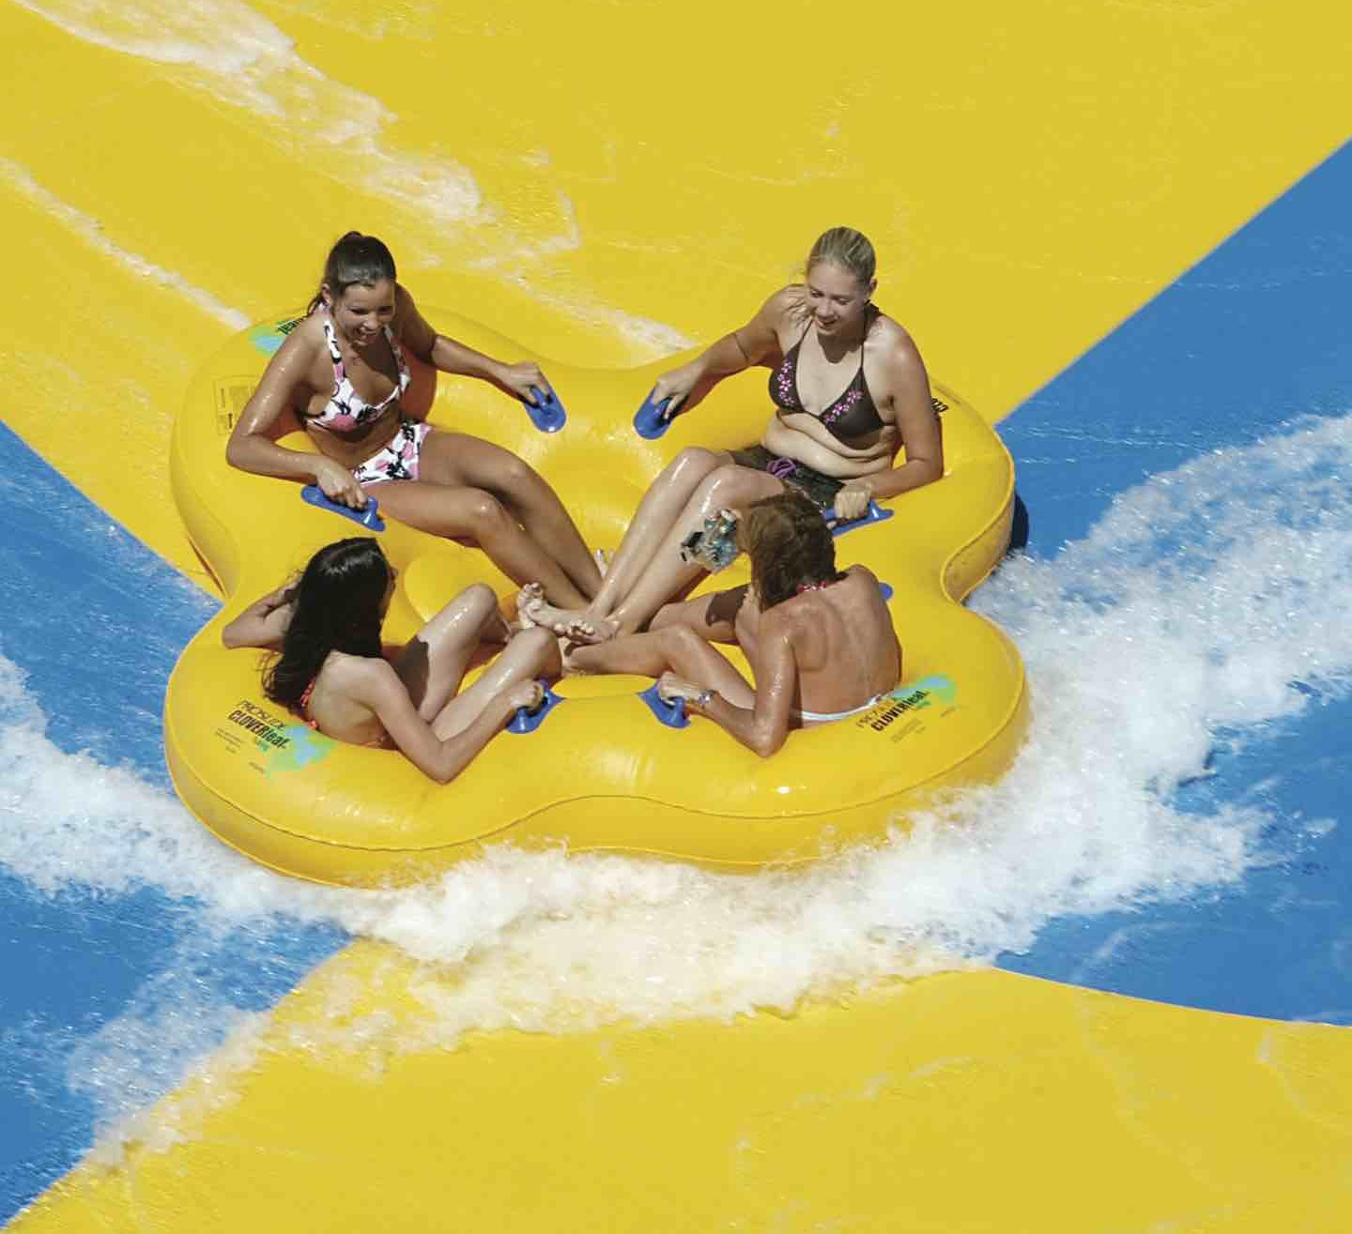
Tsunami Surge
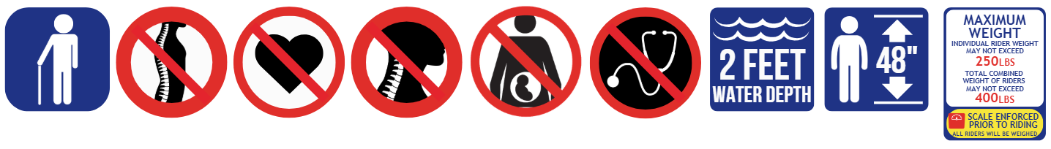Guests must be 48" tall in bare feet to ride.
Maximum Individual Rider Weight – 250 lbs.
Maximum Combined Riders Weight – 400 lbs.
Hand-held infants are not permitted to ride slides.
Double riders only.

A thrilling tube slide where riders descend down a darkened enclosed flume before exiting into an open-air half-pipe wave. The tube will slide back and forth in the slide before finally ending in a runout slide. Riders will experience high speeds and rapid movements from side-to-side. Maximum water depth is 2 feet.
Attraction Criteria: Guests are required to maintain the proper riding position. Riders will sit facing opposite of each other in the tube. Riders must sit with their backs against the side of the tube, feet braced on the foot-hole, and hands holding onto the handles. Do not rock, stop or slow your tube. Guests must have a minimum of three functioning extremities: two functioning arms and one functioning leg. Guests with a cervical collar, neck brace, broken collar bone, forearm casts, full arm casts, braced arm casts, foot or lower leg casts, full leg casts, are not permitted to ride.
Attraction Access: Access to the attraction requires climbing several flights of stairs with a tube. Riders will have to ascend the slide tower and be capable of safely entering the slide, on their own or with the assistance of a companion. Please use caution when entering and exiting as the tube may shift. To exit the slide, riders must utilize stairs to exit. The tube and surrounding area may also be slippery.
Scale Enforcement: A red light/green light scale is used at this attraction. All riders will be weighed prior to riding. Guests who exceed the weight requirements will not be permitted to ride.
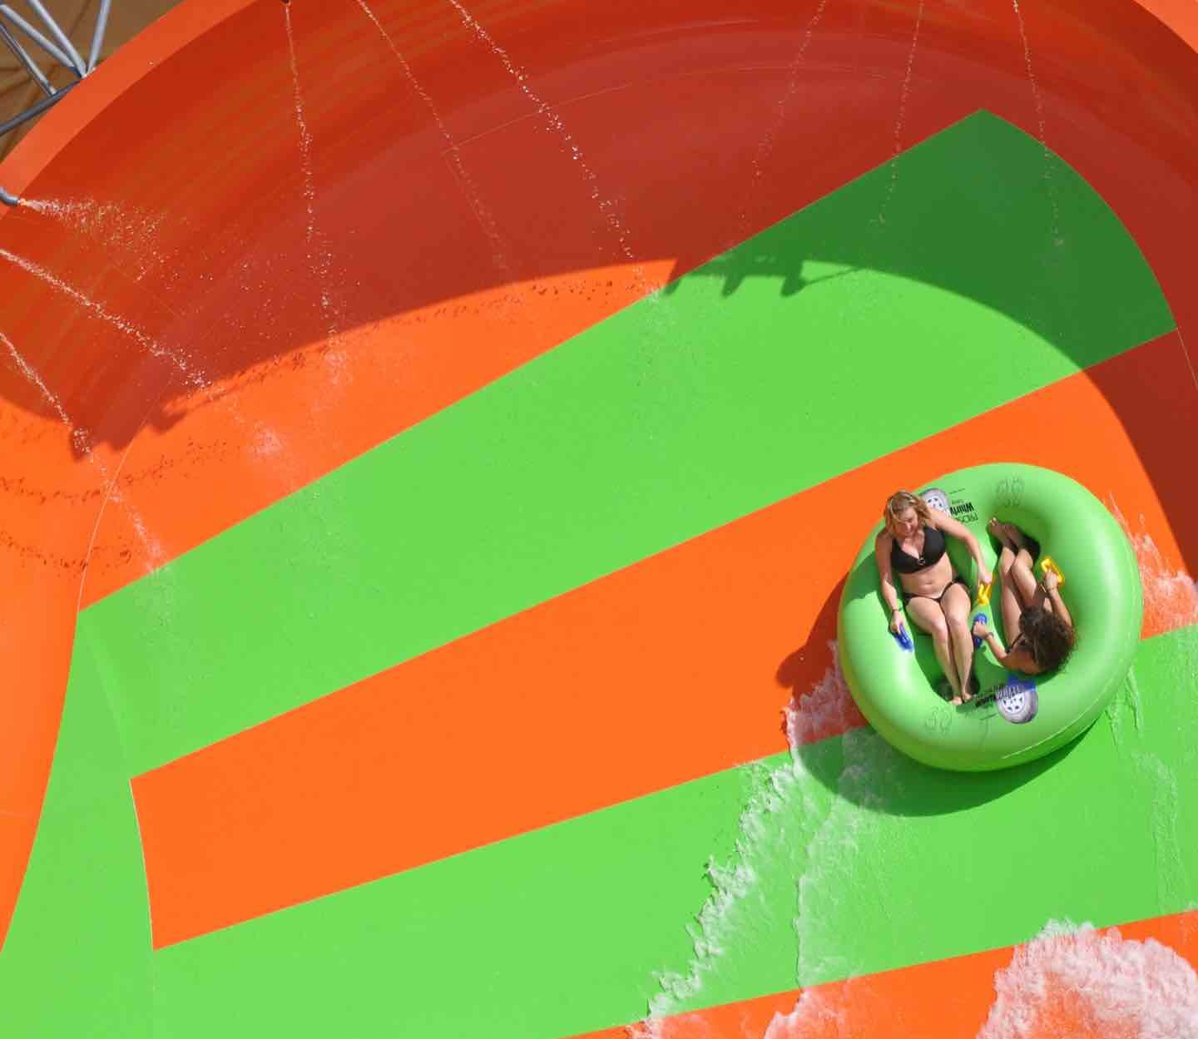
Typhoon Twister
Guests must be 48" tall in bare feet to ride.
Maximum Individual Rider Weight – 250 lbs.
Maximum Combined Riders Weight – 400 lbs.
Hand-held infants are not permitted to ride slides.
Minimum one rider; maximum two riders.
A thrilling tube slide where riders descend down a darkened enclosed flume before exiting into an open-air circular basin which sends riders spiraling in circles. Once momentum subsides, the ride continues into one last enclosed flume before finishing in a runout slide. Riders will experience high speeds and rapid movements from side-to-side. Maximum water depth 2 feet.
Attraction Criteria: Guests are required to maintain the proper riding position. Riders will sit facing opposite of each other in the tube. Riders must sit with their backs against the side of the tube, feet braced on the foot-hole, and hands holding onto the handles. Do not rock, stop or slow your tube. Guests must have a minimum of three functioning extremities: two functioning arms and one functioning leg. Guests with a cervical collar, neck brace, broken collar bone, forearm casts, full arm casts, braced arm casts, foot or lower leg casts, full leg casts, are not permitted to ride.
Attraction Access: Access to the attraction requires climbing several flights of stairs with a tube. Riders will have to ascend the slide tower and be capable of safely entering the slide, on their own or with the assistance of a companion. Please use caution when entering and exiting as the tube may shift. To exit the slide, riders must utilize stairs to exit. The tube and surrounding area may also be slippery.
Scale Enforcement: A red light/green light scale is used at this attraction. All riders will be weighed prior to riding. Guests who exceed the weight requirements will not be permitted to ride.
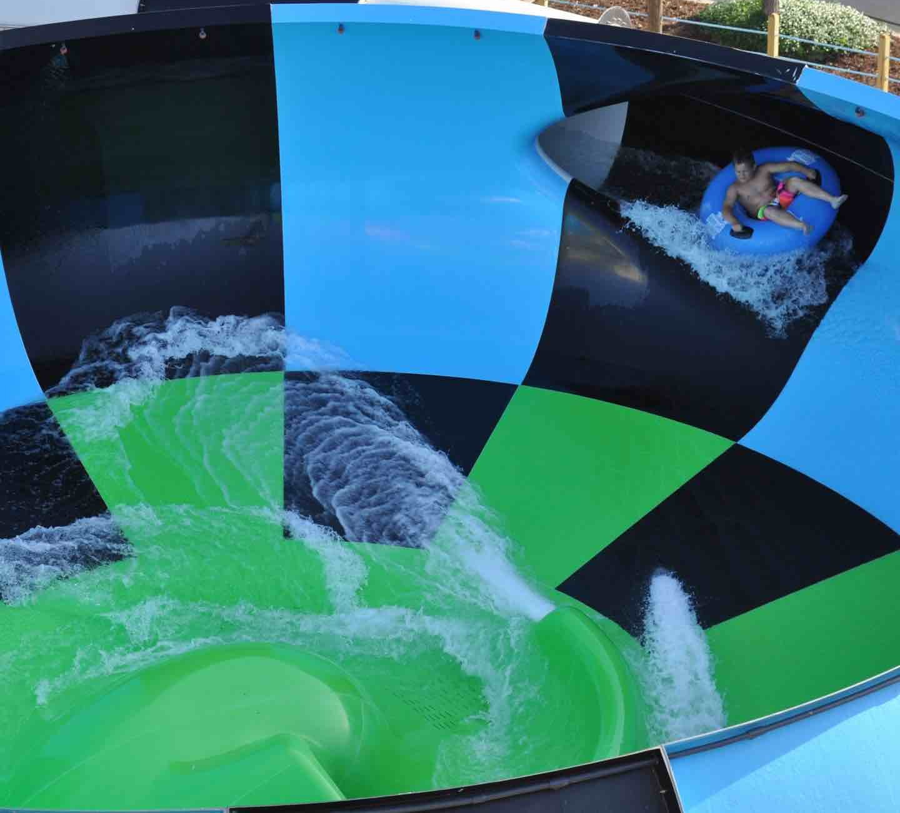
Wahoo Racer
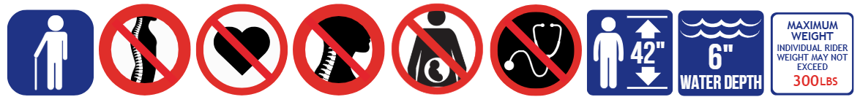

Guests must be 42" tall in bare feet to ride.
Maximum Individual Rider Weight – 300 lbs.
Hand-held infants are not permitted to ride slides.
Maximum one rider per slide.

An exciting slide complex that has riders slide head first on a mat down flumes into a runout. Maximum water depth is 6 inches.
Attraction Criteria: Guests are required to maintain the proper riding position. Lie down on your stomach, head first, hold on to the handles and keep your head down. Keep elbows and knees tucked inward towards the body with your feet held upwards. Do not rock, stop or slow your mat. Guests must have a minimum of three functioning extremities: two functioning arms and one functioning leg. Guests with a cervical collar, neck brace, broken collar bone, forearm casts, full arm casts, braced arm casts, foot or lower leg casts, full leg casts, are not permitted to ride.
Attraction Access: Access to the attraction requires climbing several flights of stairs with a mat. Riders will have to ascend the slide tower and be capable of safely entering the slide, on their own or with the assistance of a companion. Please use caution when entering and exiting as the mat may shift. To exit the slide, Guests must step out of the runout slide. The mat and surrounding area may also be slippery.
