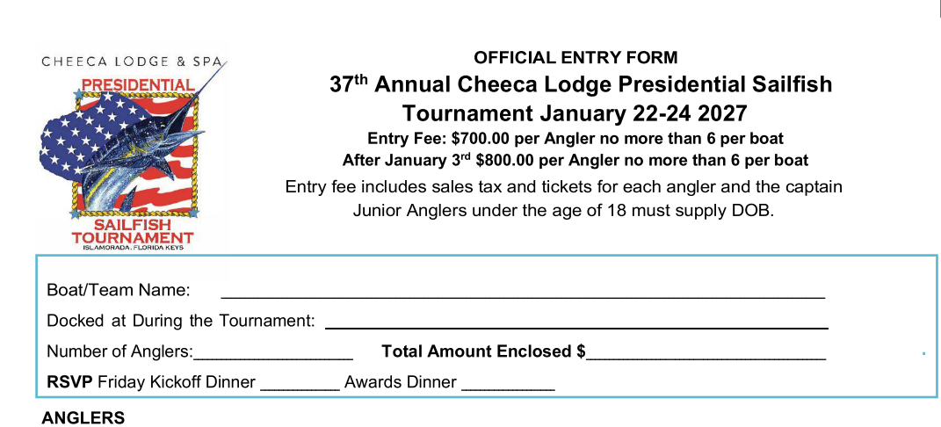

1ST Angler Name:________________________________ City_____________________State____ Zip______
Email: CK if Female Angler Shirt Size
Signature: Cell # Jr. Angler DOB____________

2ND Angler Name:________________________________ City_____________________State____ Zip______
Email: CK if Female Angler Shirt Size
Signature: Cell # Jr. Angler DOB____________

3RD Angler Name:________________________________ City_____________________State____ Zip______
Email: CK if Female Angler Shirt Size
Signature: Cell # Jr. Angler DOB____________

4TH Angler Name:________________________________ City_____________________State____ Zip______
Email: CK if Female Angler Shirt Size
Signature: Cell # Jr. Angler DOB_____________

5TH Angler Name:________________________________ City_____________________State____ Zip______
Email: CK if Female Angler Shirt Size
Signature: Cell # Jr. Angler DOB_____________

6TH Angler Name:________________________________ City_____________________State____ Zip______
Email: CK if Female Angler Shirt Size
Signature: Cell # _ Jr. Angler DOB______________

CAPTAIN



Check

if

registered

as

Angler

Shirt Size _____

37th Annual Cheeca Lodge Presidential Sailfish Tournament

Tournament Kickoff and Awards Banquet will be held at Cheeca Lodge & Spa.
Would you like someone to contact you for lodging reservations? No
Yes
*All Event RSVPs must be received no later than Friday January 16th Additional banquet tickets must be purchased in advance for Friday and Sunday events.

Tournament Contacts: Bill Coteron 305-664-4651or Liz Hill 305-451-5094

PLEASE EMAIL COMPLETED FORMS TO: bcoteron@cheeca.com

I certify that I have read the tournament rules and agree to abide by them, including rules #18 & #19.
All participants in the Cheeca Lodge & Spa Presidential Sailfish Tournament enter at their own risk. Officials, committee members and all persons connected directly or indirectly with this tournament shall be exempt from any liability suffered to any participant, entrant, sports fisherman, their companions, captains, vessels and equipment which may occur during this tournament. Participants may be photographed at this event and these photographs may be used in conjunction with promotion of this event. I understand and agree to the above paragraph and agree to abide by the Cheeca Lodge & Spa Presidential Sailfish Tournament rules.

PAYMENT INFORMATION
Please e---mail completed forms to: bcoteron@cheeca.com
If you wish to pay by check, please make them payable to Cheeca Lodge & Spa and mail to:
Cheeca Lodge Presidential Sailfish Tournament, c/o Bill Coteron P.O. Box 527, Islamorada, FL 33036.
If you prefer to pay by credit card, please visit www.Cheeca.com and look for our online Credit Card Auth Form located in the footer of our website.
Enter bcoteron@cheeca.com on the initial page in order to ensure we are in receipt of your payment

