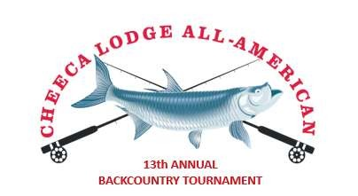
14th Annual Cheeca Lodge & Spa
All American Backcountry Tournament
November 12-14th, 2026
ENTRY FORM

ANGLER NAME:
ADDRESS:
PHONE: CELL:
EMAIL:
SHIRT SIZE: 

SMALL

MED

LARGE

XL

2
XL
*Will you be bringing a guest?

Yes

No
GUEST NAME:

GUIDE’S NAME: GUIDE’S CELL PHONE:
GUIDE’S EMAIL:
GUIDE’S SHIRT SIZE:  MED  LARGE  XL  2XL

SMALL
Will you be bringing a guest?  No GUEST NAME:

Yes

WOULD YOU LIKE SOMEONE TO CONTACT YOU REGARDING LODGING RESERVATIONS?  No

Yes

Cheeca Lodge & Spa will be offering discounted room rates for All American Tournament Anglers. You may email reservations@cheeca.com for rates or additional information.

Entry fee: $1,750 per Angler*
(*Includes entry into all social events for angler & guest, guide & guest, plus continental breakfast and boxed lunch dockside each day for anglers and guides.)
PROCEEDS FROM THE ALL AMERICAN WILL GO TO BONEFISH & TARPON TRUST.
Participants in the Cheeca Lodge & Spa All American Backcountry Fishing Tournament enter at their own risk. Officials, committee members and all persons connected directly or indirectly with this tournament shall be exempt from any liability suffered to any
participant, entrant, sports fisherman, their companions, captains, vessels and equipment which may occur during this tournament. Participants may be photographed at this event, and these photographs may be used in conjunction with promotion of this event.
I understand and agree to the above paragraph and agree to abide by the Cheeca Lodge & Spa All American Backcountry Fishing Tournament rules.

SIGN: Date: PRINT NAME:
Please email completed forms to: bcoteron@cheeca.com or mail to Cheeca Lodge (info below).
If you wish to pay by check, please make them payable to Cheeca Lodge & Spa and mail to: Cheeca Lodge All American Backcountry Fishing Tournament, c/o Bill Coteron, P.O. Box 527, Islamorada, FL 33036.
If you prefer to pay by credit card, please visit www.Cheeca.com and look for our online Credit Card Auth Form located in the footer of our website.
Enter bcoteron@cheeca.com on the initial page in order to ensure we are in receipt of your payment for more information, contact Bill Coteron at (305) 587 0574.

